STUDENTS INVESTIGATING PRIMARY SOURCES – Super Sized!
Big U.S. History Ideas Through Political Cartoons: 1898-1940
How do the political cartoons illustrate big ideas in U.S. history?
An Activity for High School U.S. History
Benchmark Correlations
SS.912.A.4.1 – Analyze the major factors that drove United States imperialism.
Benchmark Clarification: Students will trace the origin, course, and/or consequences of the Spanish-American War.
Benchmark Clarification: Students will identify the issues, challenges, and/or problems that were raised in the governing of a U.S. overseas empire.
SS.912.A.4.5 – Examine causes, course, and consequences of United States involvement in World War I.
Benchmark Clarification: Students will identify the general causes of World War I, including how political alliances, imperialist policies, nationalism, and militarism each generated conflict in World War I.
Benchmark Clarification: Students will identify the reasons for United States involvement in World War I and how involvement in the war was justified to the American public.
Benchmark Clarification: Students will explain the cause-and-effect relationships that resulted in American intervention in World War I.
Benchmark Clarification: Students will identify the major events and issues that affected the home front.
SS.912.A.5.5 – Describe efforts by the United States and other world powers to avoid future wars.
Benchmark Clarification: Students will describe the various domestic and international peace and relief efforts in which the United States was involved following World War I.
SS.912.A.6.2 – Describe the United States’ response in the early years of World War II (Neutrality Acts, Cash and Carry, Lend Lease Act).
LAFS.910.RH.1.1 – Cite specific textual evidence to support analysis of primary and secondary sources, attending to such features as the date and origin of the information.
LAFS.1112.RH.1.1 – Cite specific textual evidence to support analysis of primary and secondary sources, connecting insights gained from specific details to an understanding of the text as a whole.
LAFS.910.RH.1.2 – Determine the central ideas or information of a primary or secondary source; provide an accurate summary of how key events or ideas develop over the course of the text.
LAFS.1112.RH.1.2 – Determine the central ideas or information of a primary or secondary source; provide an accurate summary that makes clear the relationships among the key details and ideas.

Time
This SIPS is super sized! This activity will take 1-2 class periods depending on student background knowledge. This activity can be used to introduce big U.S. history concepts from 1898-1940 or as a review prior to the end-of-course U.S. history assessment. To shorten the activity, reduce the number of stations students visit using fewer cartoons and associated graphic organizers.

Full Document Citations
See Pages 31 and 32

Activity Documents and Handouts
- Big U.S. History Ideas Graphic Organizer Packets, Pages 3-9, print one copy of all graphic organizers for each student and one additional copy for each station
- Station Placards, Pages 10-30, print one copy of each placard to be cut into three pieces
Teacher Note: Prior to the start of this activity, cut out the political cartoon, caption and summary statement into three separate pieces. Place a copy of one graphic organizer and the related cutouts at each station. Be sure to mix up the political cartoons, captions and summaries at each station so that students have to match the ideas together. If you have multi-colored copier paper available, print the set of political cartoons for each station on the same color paper. This will ensure that cartoons, captions and summary statements don’t get mixed up between stations.

Activity Vocabulary
Allied Powers - a group of nations that fought together against the Central Powers during World War I; included Russia, France, British Empire, Italy, the U.S., Japan, Romania, Serbia, Belgium, Greece, Portugal, Montenegro
annexation - the act of adding or incorporating new territory into a city, country or state
big stick diplomacy - from the phrase “speak softly and carry a big stick” credited to President Theodore Roosevelt, this diplomatic approach is the use of negotiations with the threat of force
dollar diplomacy - the use of a country's financial power to extend its international influence
imperialism - a policy in which one country gains or expands political and/or economic influence over foreign lands through military conquest or economic supremacy
Kellogg Briand Pact - an agreement to outlaw war signed by 15 nations on August 27, 1928, a peacekeeping effort after World War I
League of Nations - an organization created after World War I to prevent future wars and encourage collaboration between nations
Neutrality Acts - a series of acts passed by Congress and signed by President Franklin Roosevelt after World War I to limit the United States’ involvement in future wars
Spanish American War - a conflict between the United States and Spain in 1898 that ended Spanish colonial rule in the Americas and resulted in U.S. acquisition of territories in the western Pacific and Latin America
Treaty of Versailles - a peace document signed on June 28, 1919, at the end of World War I, by the Allied Powers and Germany
World War I - a war between the Allied Powers (including Russia, France, British Empire, Italy, the U.S., Japan, Romania, Serbia, Belgium, Greece, Portugal, Montenegro), and the Central Powers (including Germany, Austria-Hungary, Turkey, Bulgaria); that lasted from 1914 to 1918

- Place students into pairs and pass out the Big U.S. History Ideas Graphic Organizer packets, one per student.
- Project the PowerPoint presentation and use Slides 1-3 to explain to students that they are going to use political cartoons to understand some big U.S. history concepts during the 1898-1940 time period.
- Project Slide 4 and direct student attention to Graphic Organizer 1. Instruct students to work with their partner to read the paragraph together and circle the history vocabulary terms.
- Have students share out the terms they identified. Project Slide 5 to ensure that students have circled all of the key history terms. Teacher Note: Depending on what has already been taught, check to make sure that each student understands the meaning of the terms that they have circled.
- Pose the following question to the students: What can you predict about the political cartoons on this graphic organizer based on the key terms you circled?
- Direct students back to the packet and instruct students to work with their partner to read and circle the key history terms for the remaining graphic organizers.
- Circulate through the class and check for student understanding of the key terms and concepts.
- Use Slides 6-11 of the PowerPoint to review the remaining graphic organizers as a whole class.
- Create seven stations around the room. At each station place a graphic organizer and the corresponding political cartoons, captions and summaries. Teacher Note: Be sure to mix up the political cartoons, captions, and summaries at the station so that students have to match the ideas together.
- Project Slide 12 and merge the student pairs into small groups. You will need seven groups total. Place one group at each of the stations.
- Explain to students that they will participate in a carousel activity, moving from one station to the next to connect the political cartoons on their graphic organizers to the correct summary and caption.
- Project Slide 13 of the PowerPoint and instruct students to reread the paragraph on the graphic organizer.
- Project Slide 14 and instruct students to follow the directions on the graphic organizer to match the correct description and caption for each political cartoon and to respond to the question on the graphic organizer: How does the cartoon match the caption? Teacher Note: If needed, model the activity for the students before they begin.
- Provide 5-7 minutes for students to work at their station and complete the graphic organizer.
- Project Slide 15 and have the groups rotate to each station, providing 5-7 minutes for student groups to work at each station.
- Instruct students to return to their seats and work with their group members to make any final notes on their graphic organizers. Rotate through the groups to check student work.
- Close the activity by providing students with the following prompt: “Choose one graphic organizer explain how the political cartoons on that graphic organizer relate to each other and to the title of the graphic organizer. Write your response in paragraph form and hand it in as an exit slip.”
Enrichment Suggestion: Have students select a title of one of the graphic organizers and have them create their own political cartoon. Instruct students to create a caption and summary to accompany their cartoon.
Name: ____________________________ Date: _____________

Graphic Organizer 1: War with Spain and the Age of Imperialism, 1898-1899
The 1898 Spanish-American War signaled an expanded geographic focus in America’s foreign affairs from controlling the Western hemisphere to administering global possessions. The war began with Spain’s resistance to an independence movement in Cuba. President William McKinley hoped to avoid U.S. involvement, but when negotiations failed, the president asked Congress to declare war. War with Spain left the U.S. holding Cuba, Puerto Rico, and the Philippines. Adding these territories along with the annexation of Hawaii, sparked a fierce debate about overseas expansion.

Directions:
- Match the political cartoon with the correct description. Summarize the description in the box under the cartoon.
- Match each caption with the correct cartoon. Write the caption in the box under the cartoon.
- Respond to the following question and write your answer in the corresponding box: How does the cartoon match the caption?
Cartoon | 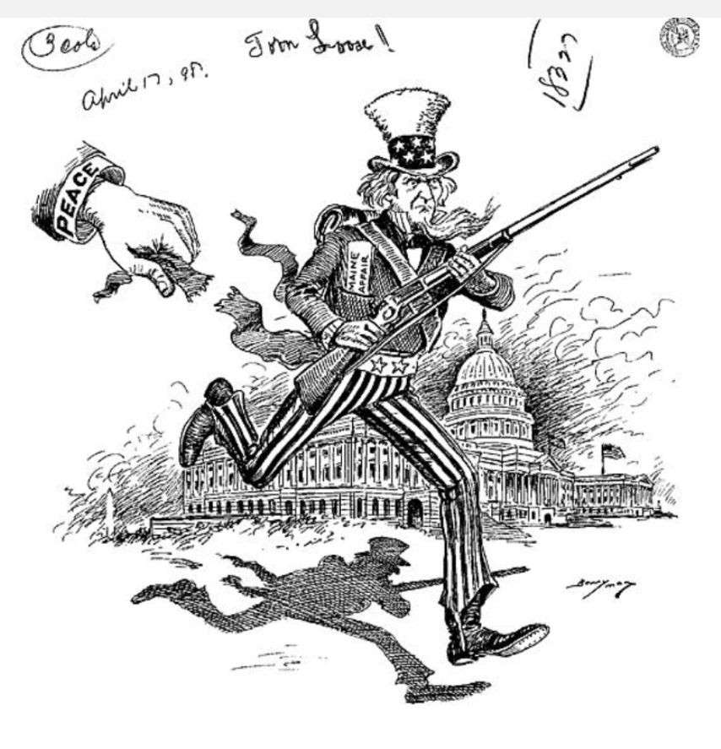 | 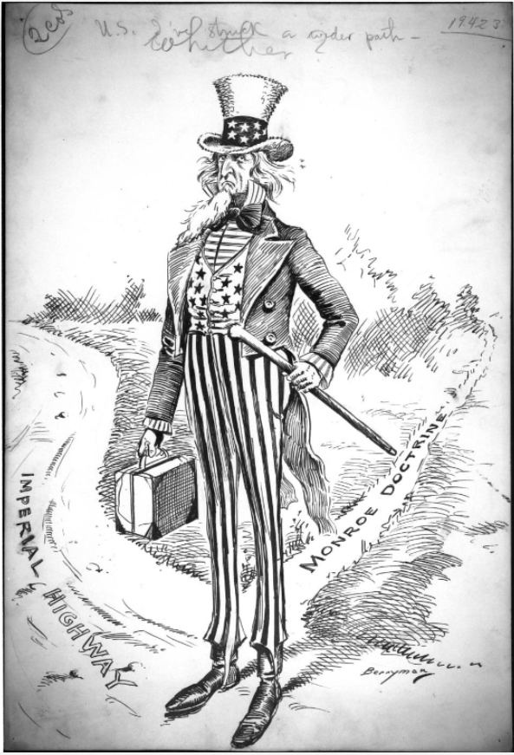 | 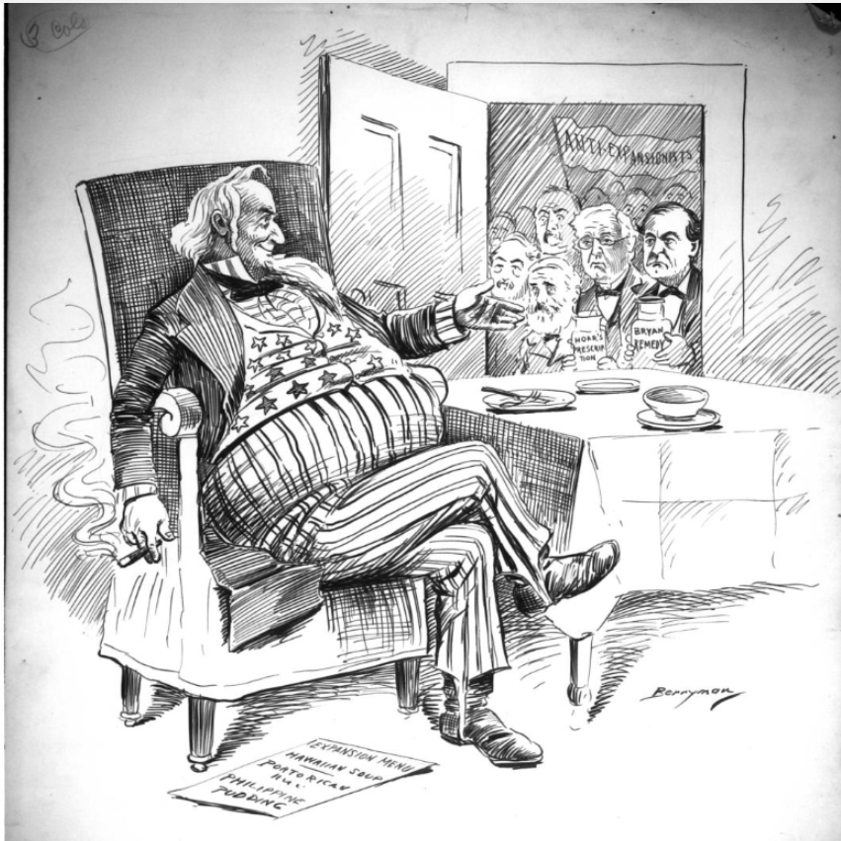
Summary of the Description
Caption
How does the cartoon match the caption?
SS.912.A.4.1
Name: ____________________________ Date: _____________

Graphic Organizer 2: The Era of the Big Stick and Dollar Diplomacy, 1900-1913
The phrases “the big stick” and “dollar diplomacy” describe American foreign policy in the decades between the War with Spain and World War I. The first phrase derives from President Theodore Roosevelt’s assertion of American power to influence world events. Roosevelt was an active president who charted an ambitious foreign policy for the nation. “Dollar diplomacy” describes William Howard Taft’s pursuit of American economic interests around the globe.

Directions:
- Match the political cartoon with the correct description. Summarize the description in the box under the cartoon.
- Match each caption with the correct cartoon. Write the caption in the box under the cartoon.
- Respond to the following question and write your answer in the corresponding box: How does the cartoon match the caption?
Cartoon | 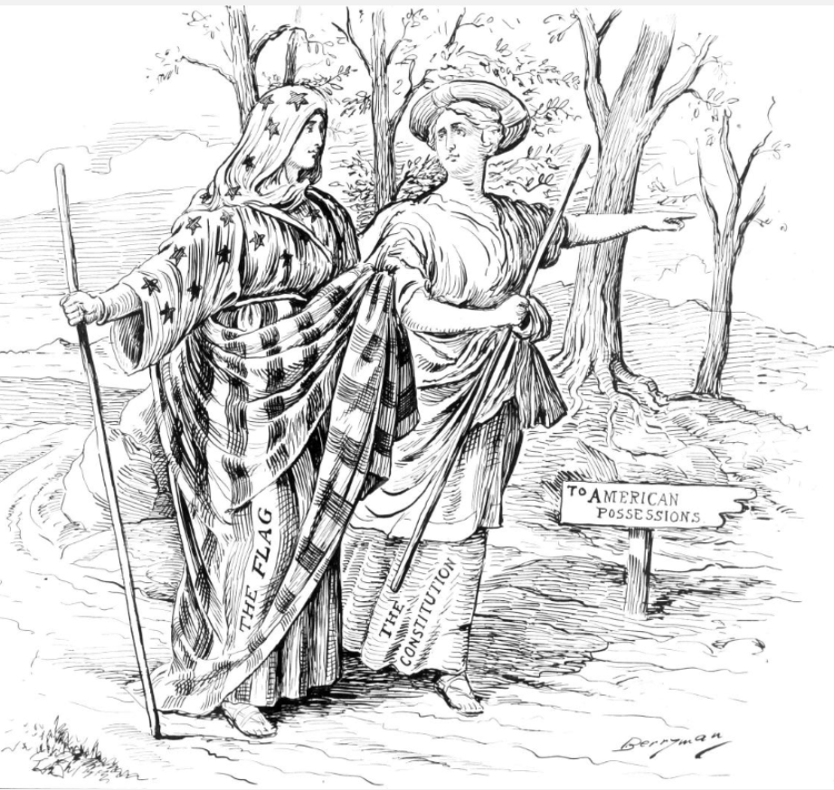 | 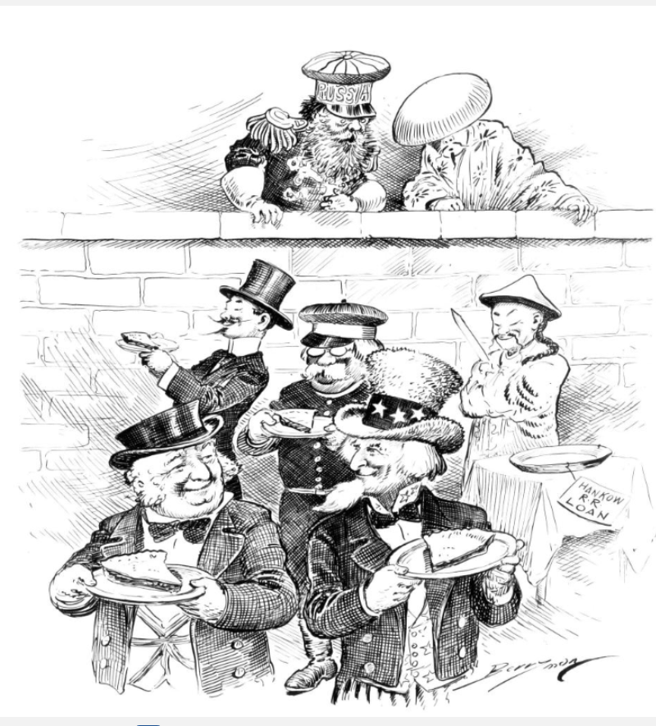 | 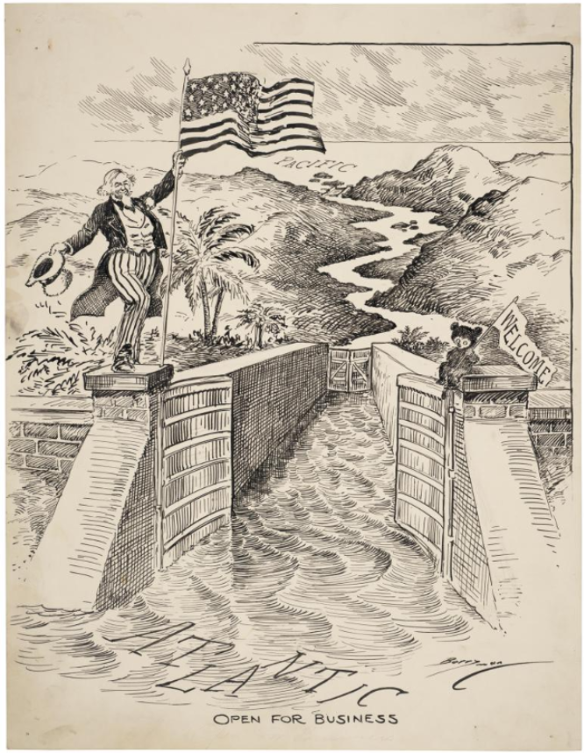
Summary of the Description
Caption
How does the cartoon match the caption?
SS.912.A.4.1
Name: ____________________________ Date: _____________

Graphic Organizer 3: World War I Begins in Europe, 1914-1916
President Woodrow Wilson urged that America should be neutral when World War I began in August 1914. For almost three years the nation endured the difficulties that arose from that policy. Clifford Berryman’s cartoons from the early years of the war reflect the nation’s commitment to neutrality, as well as the war’s unprecedented scale and destructive impact. From the start of the war, Berryman’s cartoons also depicted the effect of new military technologies such as airplanes and submarines, that threatened to end America’s insulation from the turmoil in Europe.

Directions:
- Match the political cartoon with the correct description. Summarize the description in the box under the cartoon.
- Match each caption with the correct cartoon. Write the caption in the box under the cartoon.
- Respond to the following question and write your answer in the corresponding box: How does the cartoon match the caption?
Cartoon | 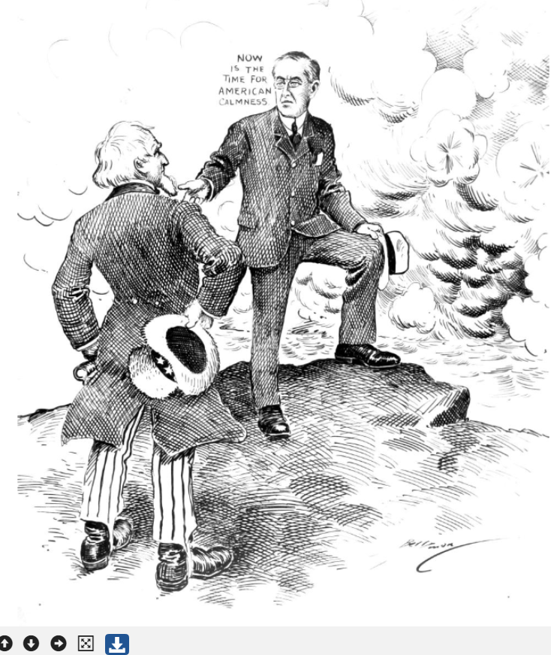 | 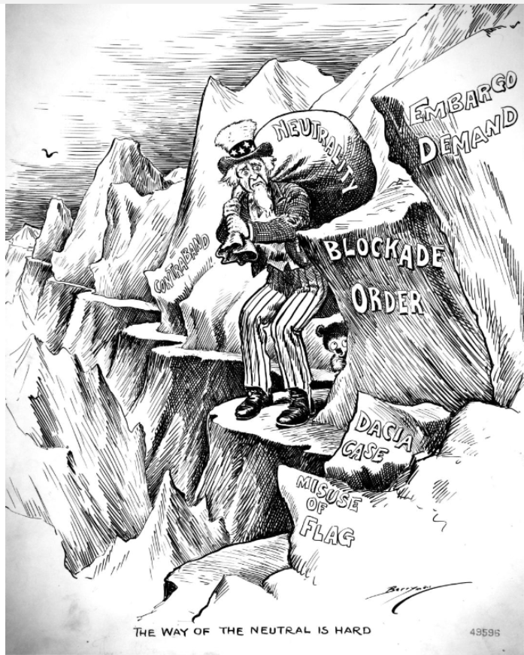 | 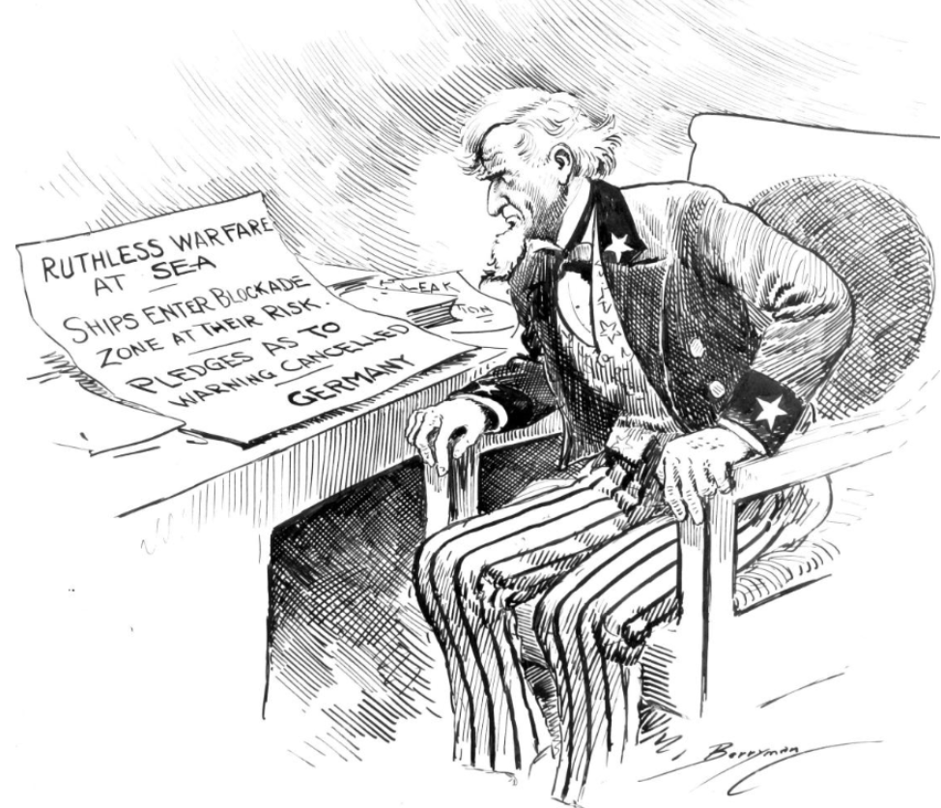
Summary of the Description
Caption
How does the cartoon match the caption?
SS.912.A.4.5
Name: ____________________________ Date: _____________

Graphic Organizer 4: America Enters World War I in 1917
Congress’s April 1917 declaration of war thrust America into a stalemated, three-year-old war. Shifting from neutrality to all-out war raised tough challenges to enlist and equip a vast military in a short span of months. Clifford Berryman’s cartoons reflected the economic, logistical, and military challenges of 1917, but also served to rally public opinion to support the war.

Directions:
- Match the political cartoon with the correct description. Summarize the description in the box under the cartoon.
- Match each caption with the correct cartoon. Write the caption in the box under the cartoon.
- Respond to the following question and write your answer in the corresponding box: How does the cartoon match the caption?
Cartoon | 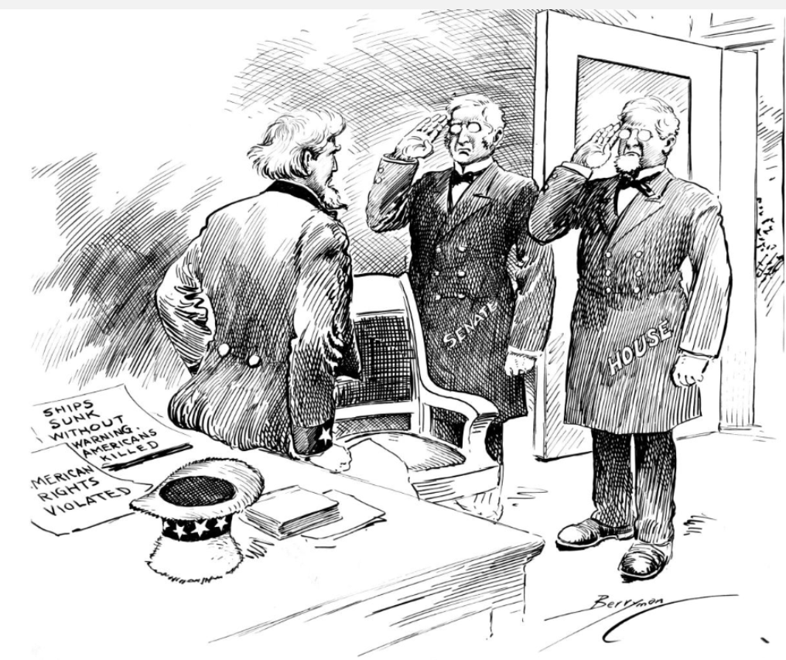 | 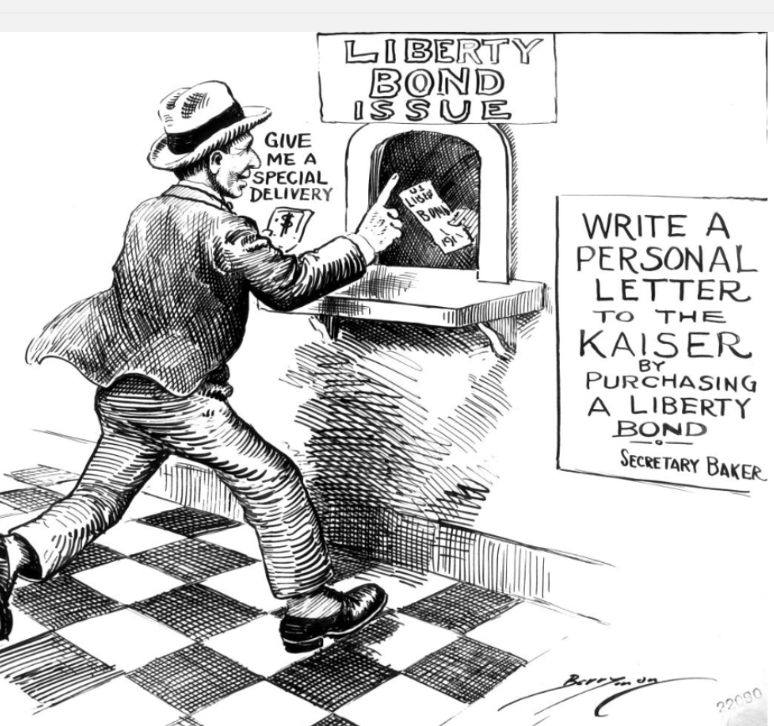 | 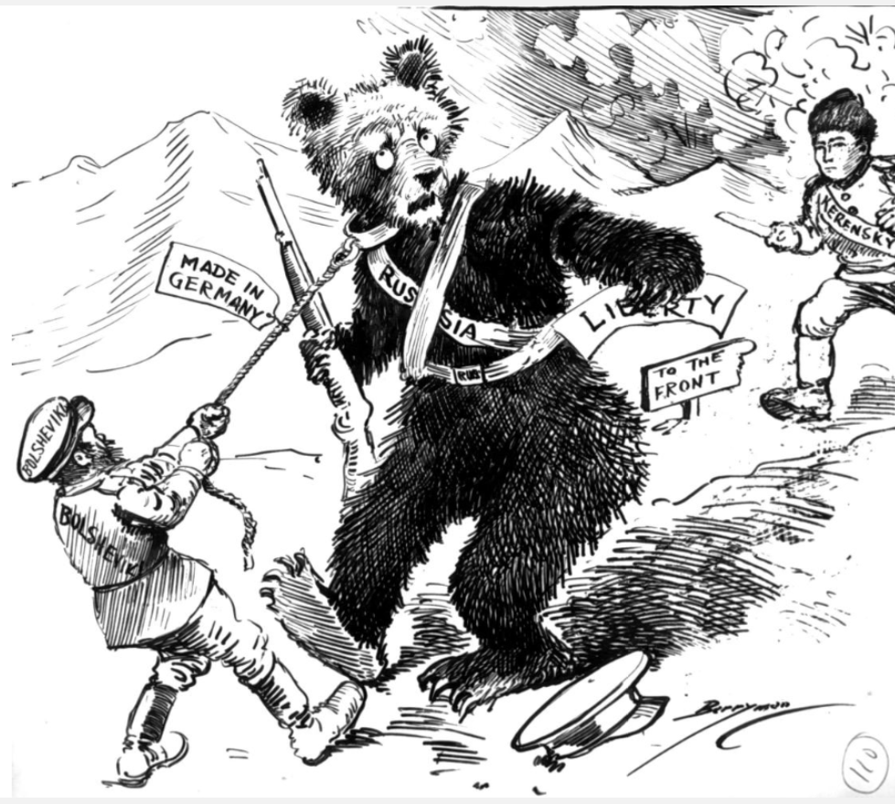
Summary of the Description
Caption
How does the cartoon match the caption?
SS.912.A.4.5
Name: ____________________________ Date: _____________

Graphic Organizer 5: America at War in Europe, 1918
Fighting on land, at sea, and in the air; in 1918 the U.S. military acted in harmony with a nation organized to achieve new levels of economic, industrial, and social unity. German submarine attacks, which had triggered the U.S. declaration of war, failed to stop a flood of U.S. soldiers and supplies from reaching France and bolstering the Allies when they stopped the final German offensive and turned the tide of battle.

Directions:
- Match the political cartoon with the correct description. Summarize the description in the box under the cartoon.
- Match each caption with the correct cartoon. Write the caption in the box under the cartoon.
- Respond to the following question and write your answer in the corresponding box: How does the cartoon match the caption?
Cartoon | 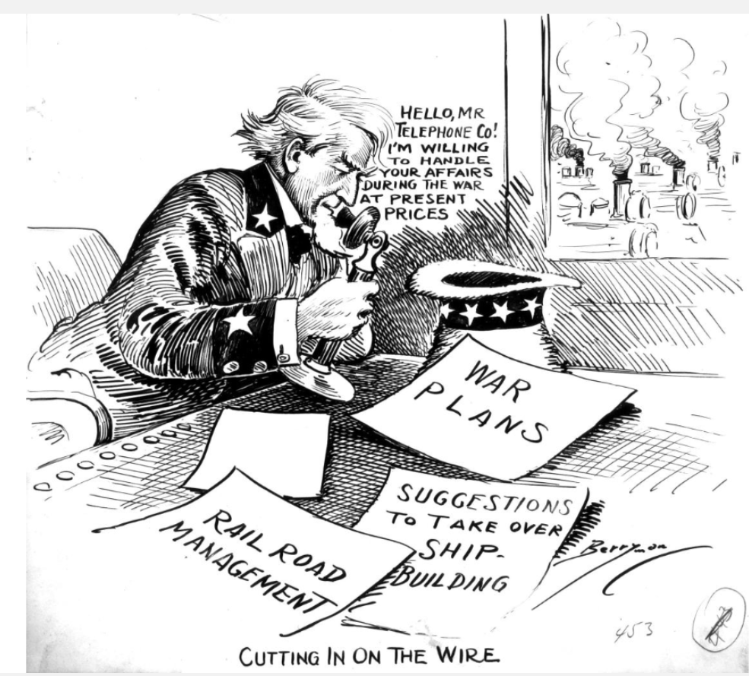 | 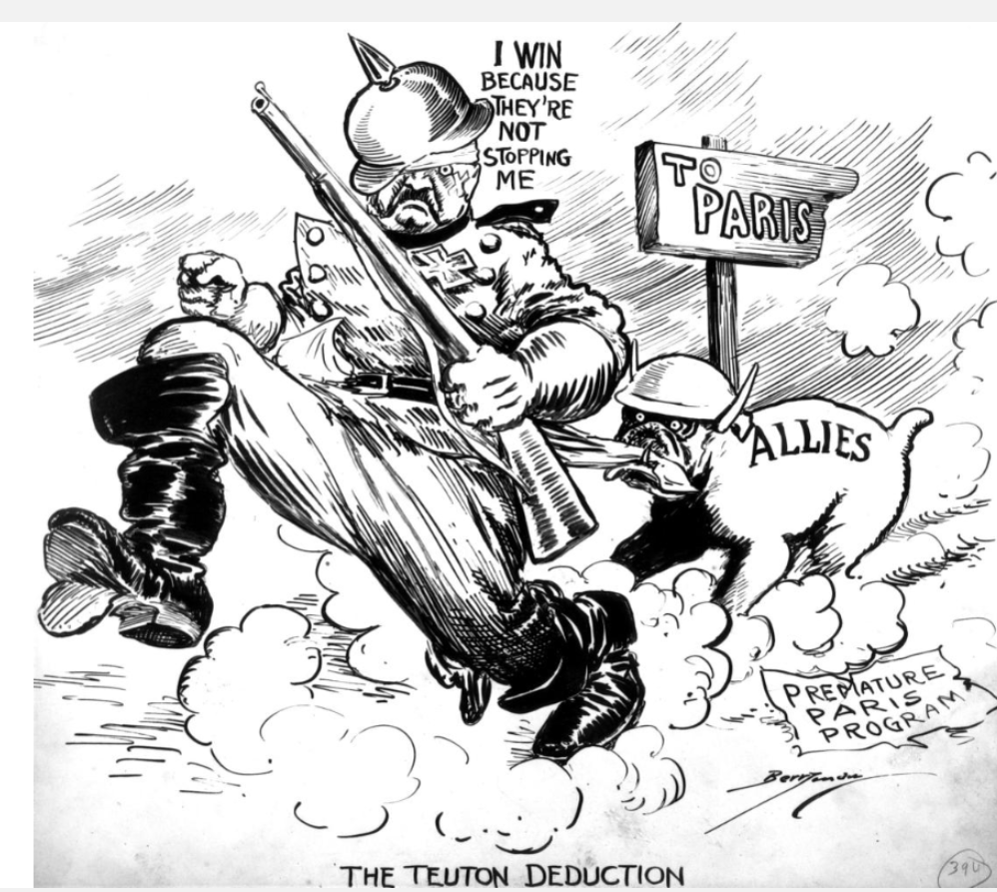 | 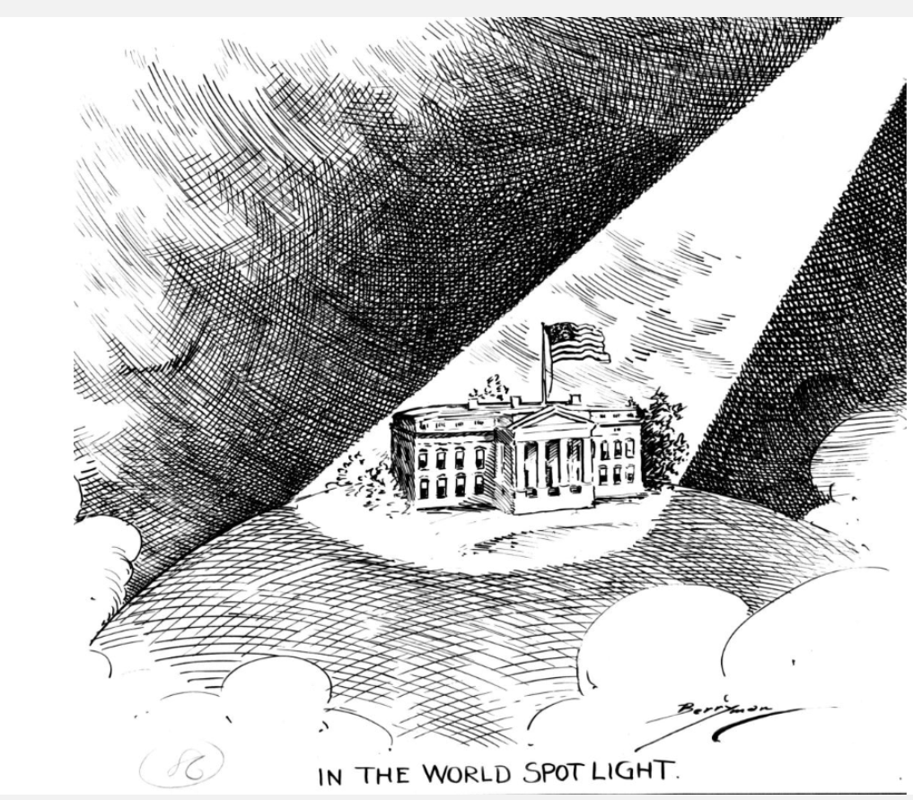
Summary of the Description
Caption
How does the cartoon match the caption?
SS.912.A.4.5
Name: ____________________________ Date: _____________

Graphic Organizer 6: The Post-War Quest for Peace, 1919-1938
President Woodrow Wilson’s optimism for a stable world after World War I helped shape the Treaty of Versailles and the League of Nations. Despite the Senate’s rejection of the treaty and America’s refusal to join the League of Nations, the United States cooperated in two decades of negotiations and treaties that held off war. The 1930s, however, saw the rise of warlike powers that started an even more destructive world war. Clifford Berryman’s cartoons reflect both hope and his realistic assessment of the limits of idealism and treaties to keep the peace.

Directions:
- Match the political cartoon with the correct description. Summarize the description in the box under the cartoon.
- Match each caption with the correct cartoon. Write the caption in the box under the cartoon.
- Respond to the following question and write your answer in the corresponding box: How does the cartoon match the caption?
Cartoon | 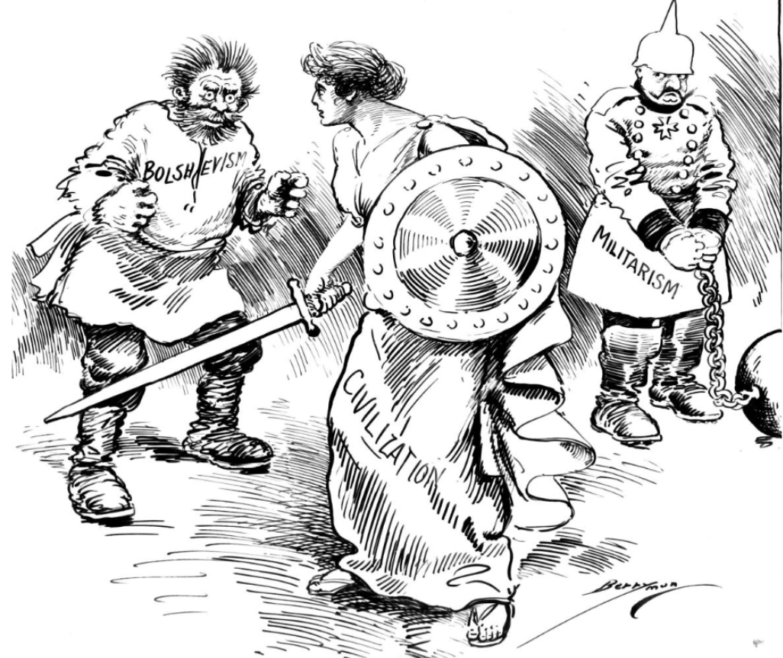 | 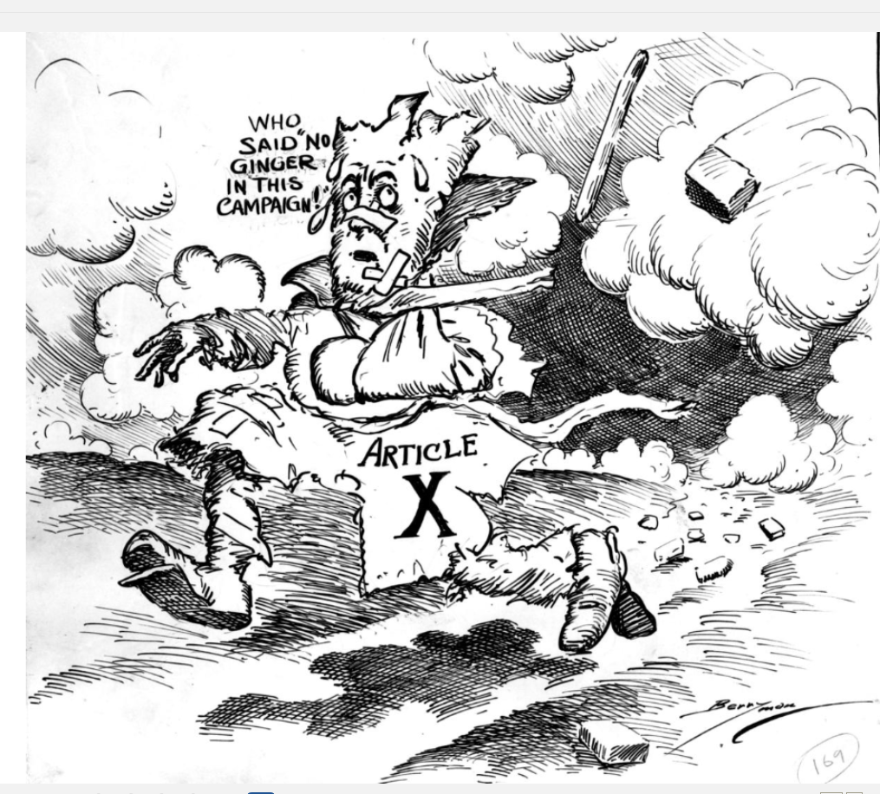 | 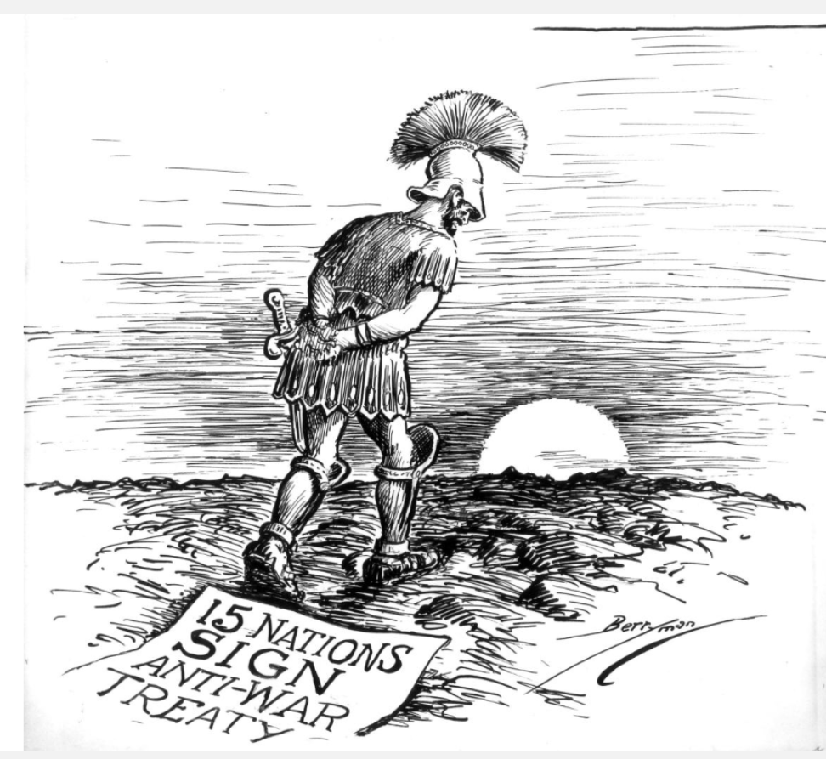
Summary of the Description
Caption
How does the cartoon match the caption?
SS.912.A.5.5

Name: ____________________________ Date: _____________

Graphic Organizer 7: Storm Clouds Gathering – World War II on the Horizon, 1939-1940
Neutrality and isolation were ideals Americans fervently clung to, although it was clear by 1940 that international agreements would not sustain world peace. The Neutrality Acts passed in 1935, 1937, and 1939 were designed to avoid the pitfalls, such as aiding belligerent nations, that many believed had entrapped the U.S. into entering World War I. As the menace posed by Germany, Italy, Japan, and the Soviet Union grew ever more alarming, Americans wrestled with how to preserve neutrality, isolation, and American interests. Clifford Berryman’s cartoons from this era captured the drama of the days and his recognition that war loomed on the horizon.

Directions:
- Match the political cartoon with the correct description. Summarize the description in the box under the cartoon.
- Match each caption with the correct cartoon. Write the caption in the box under the cartoon.
- Respond to the following question and write your answer in the corresponding box: How does the cartoon match the caption?
Cartoon | 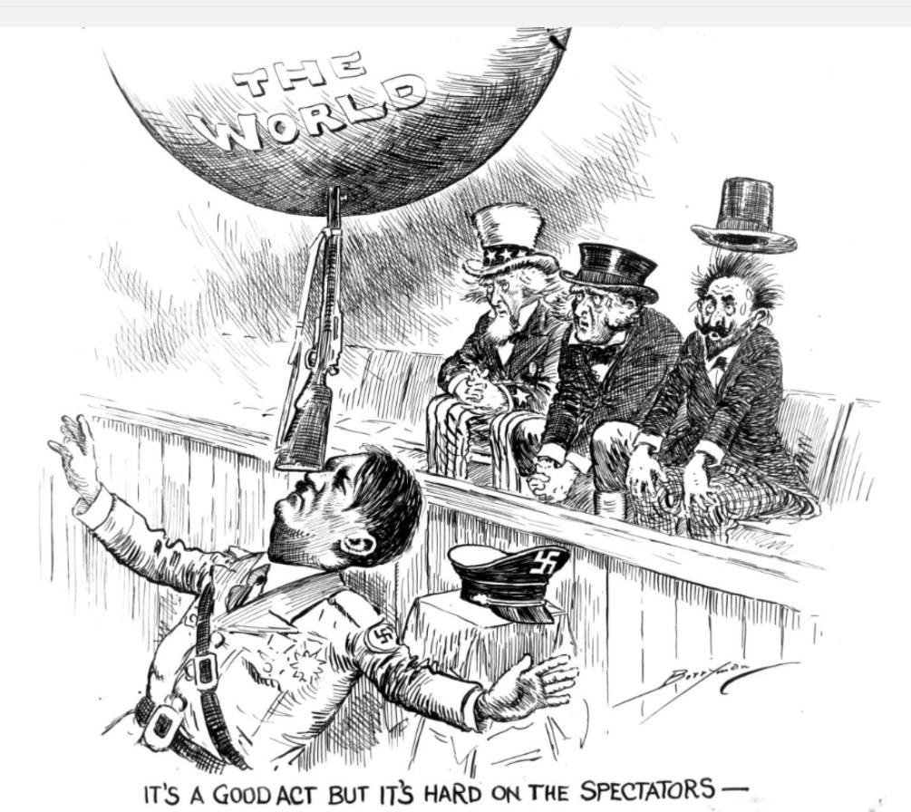 | 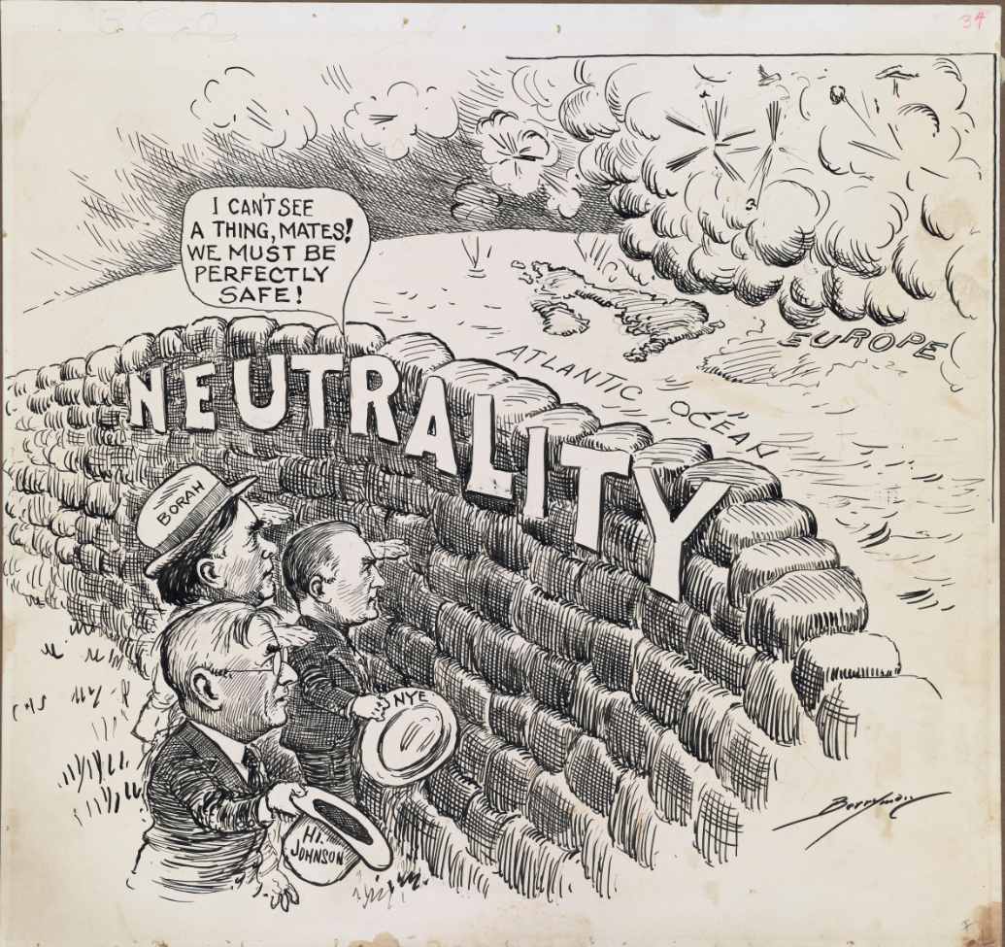 | 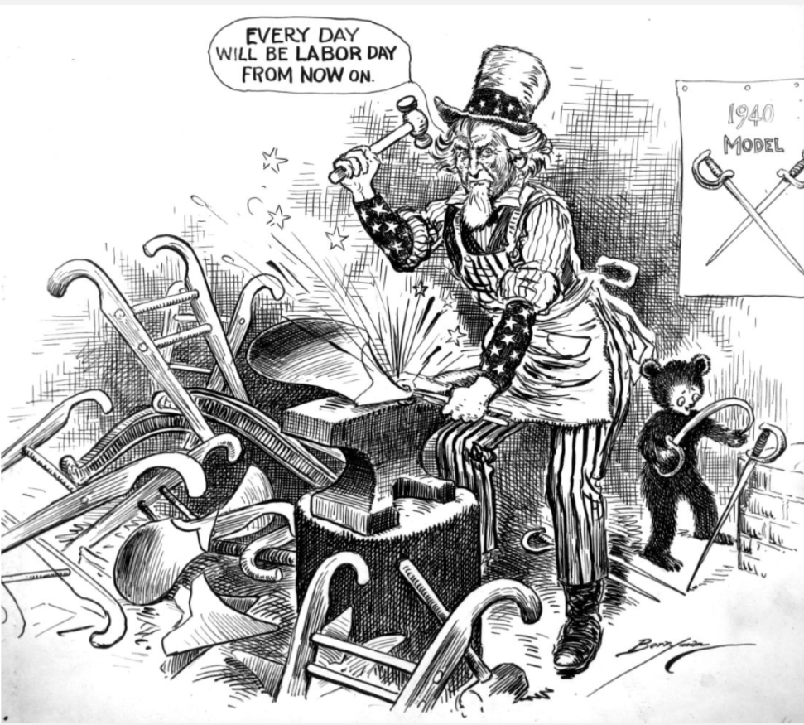
Summary of the Description
Caption
How does the cartoon match the caption?
SS.912.A.6.2

Graphic Organizer 1: War with Spain and the Age of Imperialism, 1898-1899 – Cartoon 1

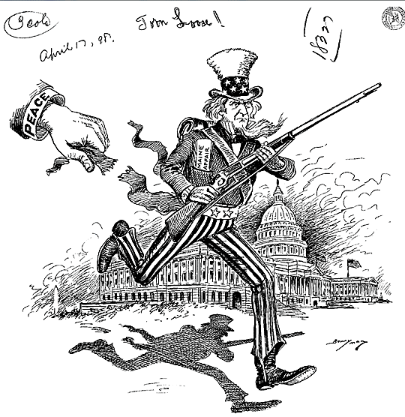

Caption | The sinking of the USS Maine helped  cause the U.S. to fight for the independence of Cuba.
Summary | An armed Uncle Sam charges from the Capitol carrying a note reading “Maine Affair” in a cartoon published on the day after a Senate resolution recognized the independence of Cuba from Spanish rule. The note refers to the explosion of the American battleship USS Maine in Havana, an event that triggered demands for U.S. involvement in the long-running struggle for independence. Spanish tactics in putting down the revolt disturbed many Americans. Although President Grover Cleveland proclaimed U.S. neutrality, sensation-driven newspapers called for war. In 1897, newly elected President William McKinley cautioned patience, but the explosion of the Maine shattered U.S. relations with Spain and led to a declaration of war on April 25, 1898.

Graphic Organizer 1: War with Spain and the Age of Imperialism, 1898-1899 – Cartoon 2

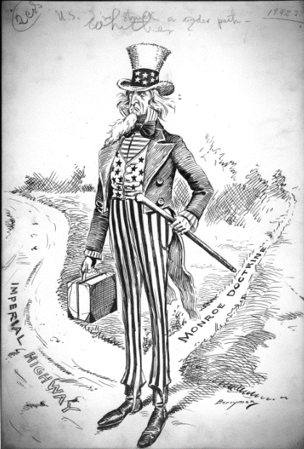
Caption | War with Spain caused the U.S. to rethink  its long-held principle of anti-colonialism.
Summary | Uncle Sam stands at the intersection of the narrow lane labeled “Monroe Doctrine” and the wider “Imperial Highway” and ponders which direction to take on the new road. Uncle Sam’s hesitation suggests the importance of his decision. Recent events had prompted the United States to re-think long-held ideas about foreign policy. Congress had declared war to free Cuba from inhumane Spanish rule, but the U.S. expanded the fighting by attacking other Spanish colonies including the Philippines and Puerto Rico. Would victory transfer these colonial possessions to American rule? As U.S. troops captured Cuba and the Philippines, President McKinley signed legislation annexing Hawaii. Uncle Sam was indeed venturing onto the imperial highway, but how far the nation would travel down this new path was not yet decided.

Graphic Organizer 1: War with Spain and the Age of Imperialism, 1898-1899 – Cartoon 3

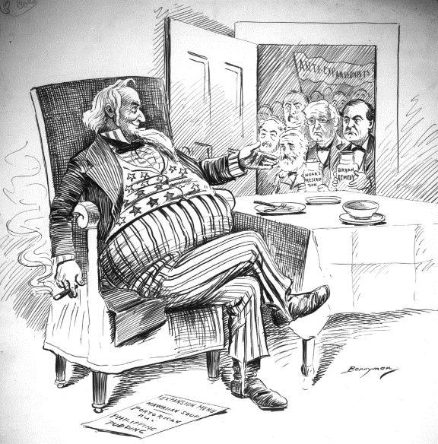

Caption | Adding territories expanded borders but  alarmed the opponents of a U.S. empire.
Summary | Uncle Sam’s expanded waistline is symbolic of the rapid pace of U.S. territorial expansion. A treaty adding Hawaii to the United States and victory over Spain brought the U.S. several new territories, including Hawaii, Puerto Rico, Cuba, and the Philippines, all listed on the menu shown in the cartoon. America paid Spain $20 million to annex the Philippines, Guam, and Puerto Rico, but the purchase only intensified the Philippine independence movement. The figures shown in the doorway represent the Anti-Expansionists in the Republican Party led by Senator George Hoar, and the Anti-Imperialist Democrats led by William Jennings Bryan.

Graphic Organizer 2: The Era of the Big Stick and Dollar Diplomacy, 1900-1913 - Cartoon 1

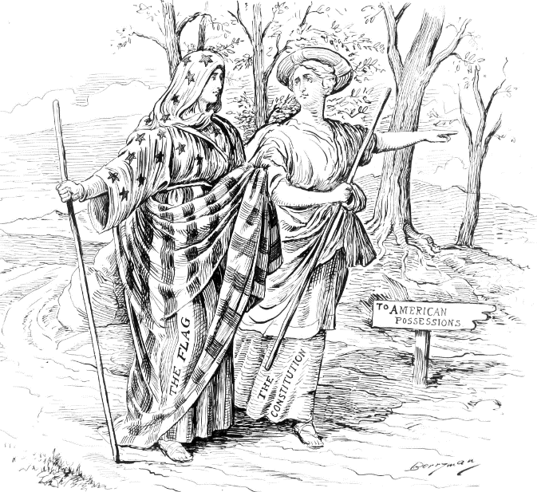

Caption | The protection of constitutional rights follows the U.S. flag.
Summary | Clifford Berryman asserts the indivisible link of the Constitution and the flag through his reference to the tale of faithful companionship told in the biblical story of Ruth and Naomi, where Naomi pledged to follow her mother-in-law Ruth wherever she went. This cartoon identifies Berryman with the position of expansionists who favored extending U.S. citizenship to territorial residents. Commercial expansionists, by contrast, favored U.S. ownership of land without extending citizenship. A third powerful faction in the debate, the Anti-Expansionists, opposed holding colonies altogether, claiming that adding territorial possessions and people transformed the United States into an empire and went against the anti-colonial founding spirit of the American republic.

Graphic Organizer 2: The Era of the Big Stick and Dollar Diplomacy, 1900-1913 - Cartoon 2

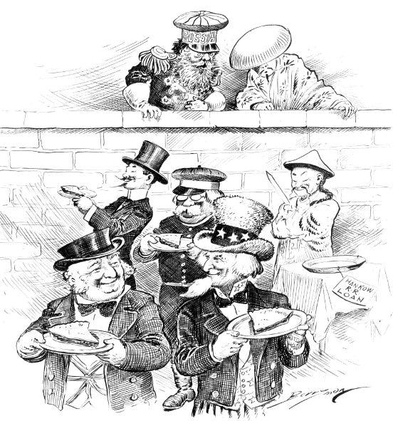

Caption | “Dollar Diplomacy” refers to using U.S. investments to gain global influence.
Summary | The cartoon refers to the 1909 railroad construction loans made by Western powers to China. The Hankou loan was originally negotiated as an arrangement exclusively between France, Germany, Great Britain, and China. The United States, feeling that its exclusion was an injustice threatening its future role in China, worked its way into the deal. Great Britain reportedly was pleased by this development as they preferred America as a partner over Germany. The cartoon reflects the closeness of the United States and Great Britain as they appear in the forefront smiling at one another. Clifford Berryman presents the loan as beneficial to its Western participants, and acknowledges the resentment of the powers who were excluded from it.

Graphic Organizer 2: The Era of the Big Stick and Dollar Diplomacy, 1900-1913 - Cartoon 3

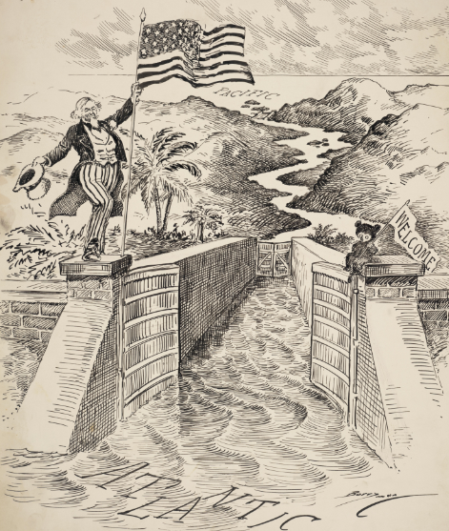

Caption | The U.S. created a path between the seas that revolutionized global trade.
Summary | The Panama Canal opened for business on the day this cartoon was published. It shows Uncle Sam welcoming ships and identifies the Atlantic and Pacific Oceans as the waterway’s endpoints. Uncle Sam proudly waves a flag, celebrating America’s triumph in completing the project. The opening ceremony for the canal was a grand affair that coincided with the first weeks of World War I. The U.S. declared that the canal would remain neutral, allowing access to all European nations. Clifford Berryman’s cartoon highlights the international significance of the canal and America’s increasing importance in the world.

Graphic Organizer 3: World War I Begins in Europe, 1914-1916 – Cartoon 1

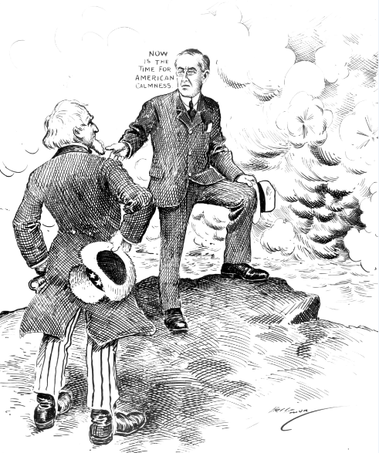

Caption | President Woodrow Wilson led a policy of U.S. neutrality  at the outbreak of World War I
Summary | Published weeks after war broke out in Europe, this image shows President Woodrow Wilson standing at the coast reasoning with Uncle Sam for American calmness in the face of the battle shown in the distance. In his August 19 statement on neutrality Wilson called upon all “thoughtful men” to be guarded in public statements about the war. He cautioned that, “The effect of the war upon the United States will depend upon what American citizens say and do…”

Graphic Organizer 3: World War I Begins in Europe, 1914-1916 – Cartoon 2

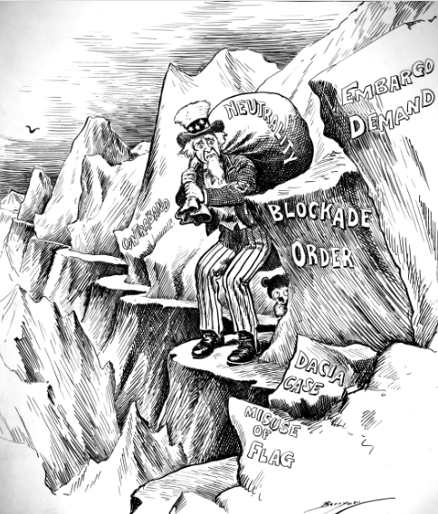

Caption | Atlantic trade was crucial to the U.S.,  but blockades made neutrality difficult to maintain
Summary | The rights of neutral countries to navigate the Atlantic were at the forefront of public attention in early 1915 when Germany imposed the world’s first submarine blockade. The cliff Uncle Sam inches along in this cartoon displays phrases showing the danger of conducting neutral trade in seas patrolled by submarines. On February 1, the headlines were dominated by news of a German submarine blockade of Great Britain. On February 10, the United States separately warned Great Britain and Germany not to interfere with U.S. shipping. A day later, Great Britain declared a blockade of German ports. The blockades raised alarms about the safety of ships flying the flags of neutral nations. They also raised the issue of ships from nations at war flying the flags of neutral nations to avoid capture. Weeks earlier, for example, the British liner Lusitania had sparked international controversy by flying the U.S. flag to avoid attack while off the coast of Ireland.

Graphic Organizer 3: World War I Begins in Europe, 1914-1916 – Cartoon 3

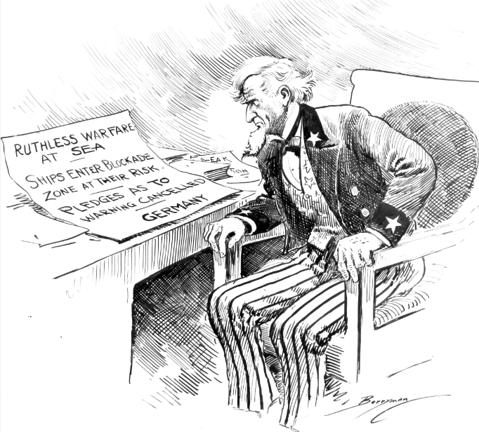

Caption | A new program of unrestricted submarine attacks on shipping  doomed U.S. neutrality.
Summary | Clifford Berryman depicts Uncle Sam’s response to the German declaration of unrestricted submarine warfare against any ships in the blockade zone around the British Isles. The new declaration was a departure from assurances Germany gave after the sinking of the Lusitania in 1915, and the Sussex Pledge in 1916, agreeing not to sink passenger vessels or merchant ships not carrying war materials. President Wilson had been re-elected to a second term in November, 1916, on the strength of his having kept the U.S. out of the war, but now faced a challenge. The U. S. was economically dependent on shipping, and believed in a right to free seas. Maintaining a policy of neutrality would mean surrendering the right to ship goods across the Atlantic and would leave American ocean travelers at the mercy of German U-boat attacks.

Graphic Organizer 4: America Enters World War I in 1917 – Cartoon 1

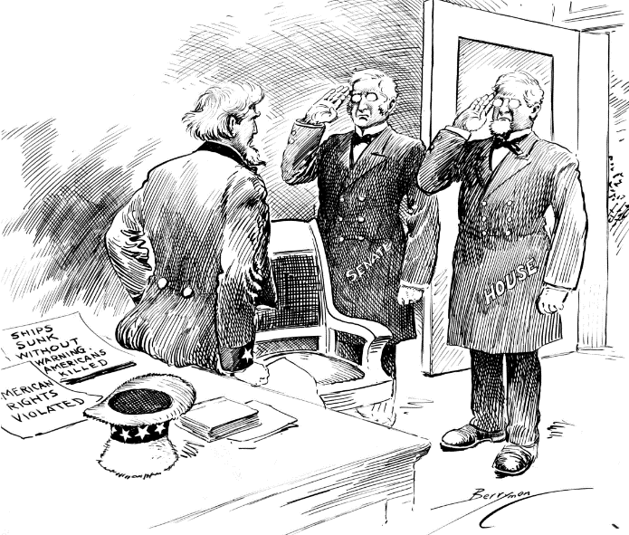

Caption | President Wilson led Congress to declare war to  “make the world safe for democracy.”
Summary | The House and Senate salute Uncle Sam as they report for duty in a cartoon published on the day the 65th Congress met to hear President Woodrow Wilson’s war message. Papers on the desk refer to the German policy of unrestricted submarine warfare that prompted Wilson to call Congress into session. Events had unfolded quickly in recent weeks. Germany had declared open war at sea on February 1, and Wilson had responded in March by arming U.S. merchant ships. In his war message to Congress, Wilson argued for America to fight against Germany for free seas and a “world made safe for democracy.”

Graphic Organizer 4: America Enters World War I in 1917 – Cartoon 2

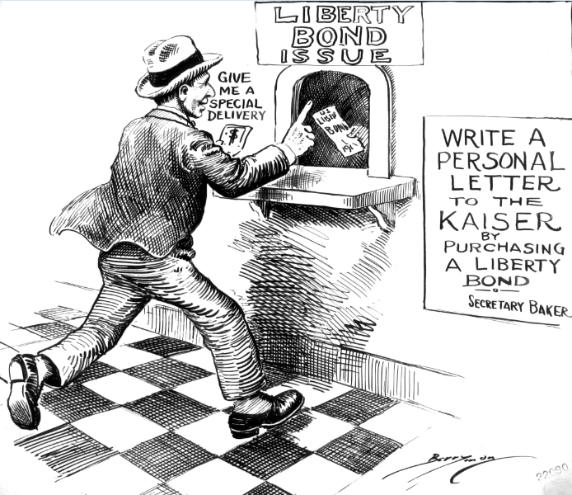

Caption | Buying Liberty Bonds helped the U.S. pay for the war and demonstrated public support.
Summary | An American purchases a liberty bond to send a message to the German Kaiser. This was one of 18 cartoons Clifford Berryman drew in October, 1917, supporting the second Liberty Bond drive. Liberty Bonds were notes issued by the U.S. Treasury and sold to the public through Federal Reserve Banks to help finance World War I. The federal government generated income to pay for the war with a combination of new taxes and money raised from bond sales. The Second Liberty Loan campaign was one of four bond drives nationally advertised through vivid posters and other media. The Liberty Bond drives proved a highly-effective means of enlisting public support for the war effort.

Graphic Organizer 4: America Enters World War I in 1917 – Cartoon 3

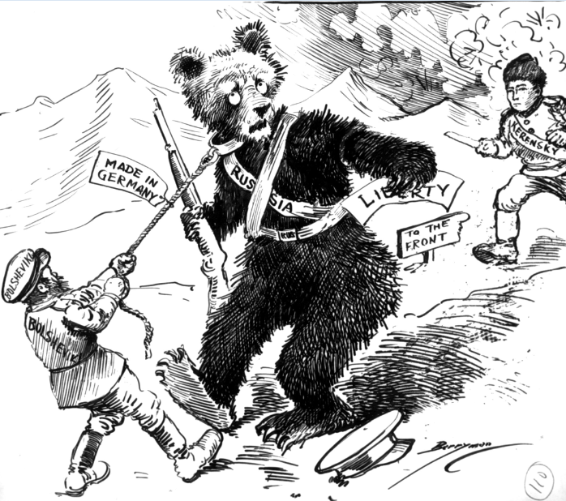

Caption | With German support, the communist Bolsheviks led Russia to leave  World War I.
Summary | The confused look on the face of the bear representing Russia in this cartoon matched the conflicting, uncertain news American readers were receiving about fighting in Russia between Bolshevik armies and supporters of Alexander Kerensky, Head of the Provisional Government that ruled Russia from July to November, 1917. Here, Kerensky is depicted as a rescuer because he pledged to continue Russia’s fight against Germany on the Eastern Front. Clifford Berryman’s image links the Bolsheviks to Germany, reflecting German support for Bolshevik leader, V.I. Lenin, who favored peace with Germany. The Bolsheviks gained control of the Russian government in November, 1917, and negotiated the Treaty of Brest-Litovsk with Germany, ending Russian participation in the war.

Graphic Organizer 5: America at War in Europe, 1918 – Cartoon 1

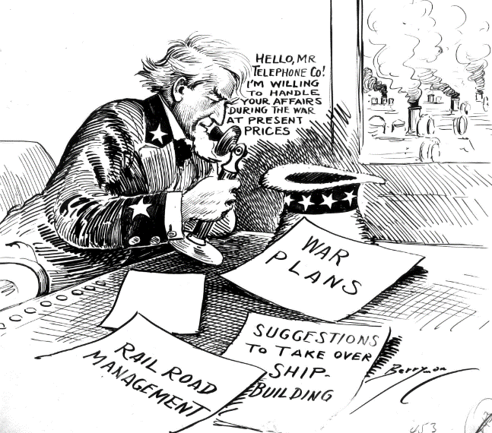

Caption | The U.S. government managed the railroad and telephone systems for wartime efficiency.
Summary | “Cutting in on the Wire” shows Uncle Sam calling “Mr. Telephone Co.” and offering to take over phone service during the war. This cartoon was drawn at the beginning of the United States Postal Service’s push to acquire the District of Columbia’s telephone service from the Chesapeake & Potomac Telephone Company. Memos on Uncle Sam’s desk list other related industries that were nationalized in the interest of the war efforts. Congress passed a joint resolution on July 16, 1918, granting the president power to nationalize the telephone systems for the duration of the war. President Wilson announced that the Post Office would take control of the phone system on July 31. Following the war, legislation was passed returning the phone system to private ownership.

Graphic Organizer 5: America at War in Europe, 1918 – Cartoon 2

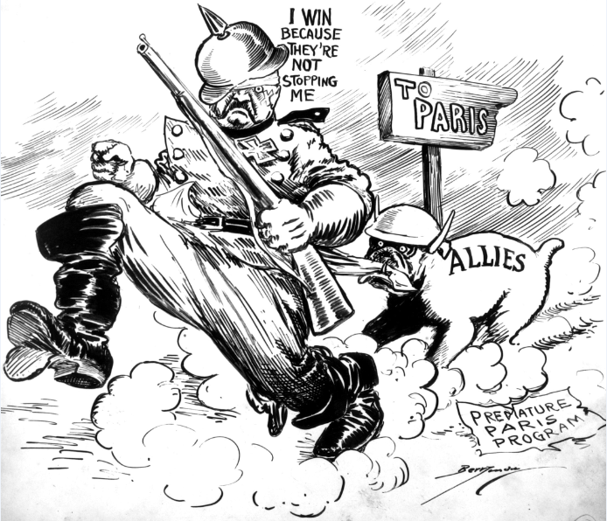

Caption | U.S. troops were key to the Allies’ halting the final German assault on Paris.
Summary | This cartoon, featuring a bulldog labeled “Allies” yanking at the coat of a bandaged and fleeing German soldier, represents the German retreat after the Second Battle of the Marne. A sign pointing toward Paris faces in the opposite direction, and the phrase “premature Paris program” is written on a note lying in the dust. A turning point in World War I, the battle began on July 15, 1918, as the Germans marched toward Paris hoping to capture the French capital and end the war. An Allied counteroffensive had begun on July 18 and pushed the German lines back 30 miles. This effort involved more American soldiers than any battle fought since the Civil War. The cartoon dramatizes the German retreat and celebrates an Allied victory in which Americans played a leading role.

Graphic Organizer 5: America at War in Europe, 1918 – Cartoon 3

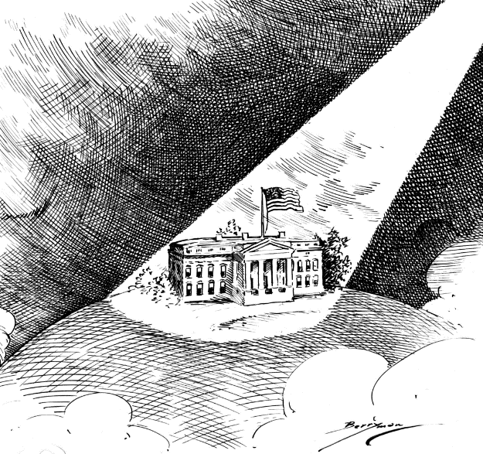

Caption | Contributions to Allied victory in World War I  made the U.S. a leading world power.
Summary | “In the World Spotlight” appeared on the front page of The Evening Star as President Woodrow Wilson was considering a request for peace received from the new German Chancellor, Prince Maximilian of Baden. The cartoon was published alongside an article reporting Wilson’s insistence that Germany remove its troops from invaded countries as a precondition to peace. Clifford Berryman’s cartoon illustrates the central role of Wilson and the United States in preparing for the peace negotiations that would end World War I. Wilson seized the international spotlight when he outlined his “Fourteen Points” for peace in an address to Congress on January 8, 1918.

Graphic Organizer 6: The Post-War Quest for Peace, 1919-1938 – Cartoon 1

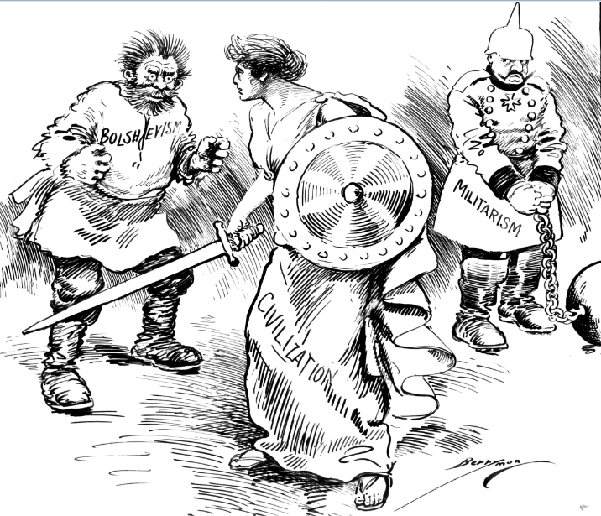

Caption | The Russian Bolsheviks’ belief in communist revolution  threatened world stability.
Summary | A classical Greco-Roman woman armed with a sword and shield representing civilization stands cautiously between a wild-haired, frightening man representing bolshevism and a handcuffed and chained German soldier representing militarism. The cartoon suggests that although civilization has beaten Germany, it now faces a new threat. An article published in The Evening Star on the same day suggested that the Allies saw it as America’s responsibility to “police” Europe. Clifford Berryman’s cartoon reflects the European fear that bolshevism would solidify its control over Russia and fill the power vacuum left by the war in Germany and Eastern Europe. Published at a time when hunger and political instability fueled widespread revolutionary movements, this cartoon reflects an uneasy realization that the war fought by America to make the world safe for democracy has not ended, but rather has expanded into a wider responsibility of preserving civilized order.

Graphic Organizer 6: The Post-War Quest for Peace, 1919-1938 – Cartoon 2

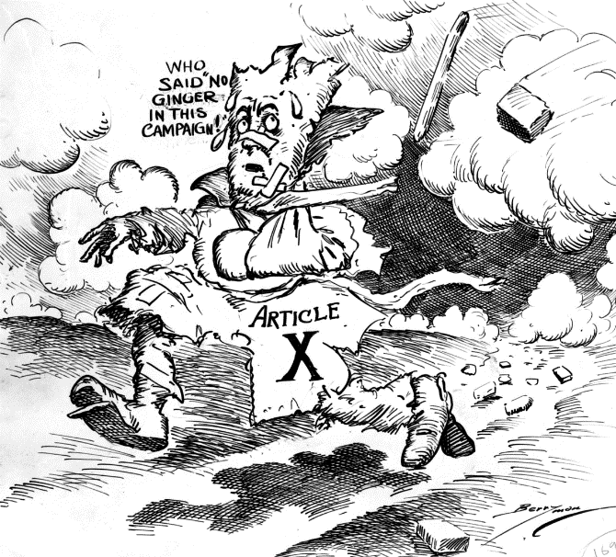

Caption | The Senate rejected the Treaty of Versailles  because its Article X created a League of Nations.
Summary | The Treaty of Versailles and U.S. membership in the League of Nations were central issues in the 1920 presidential campaign. Article X of the Covenant of the League of Nations required members to assist any other member in the event of an invasion or attack. President Woodrow Wilson had submitted the Treaty for Senate ratification, but it was rejected due to opposition led by Senators opposed to foreign entanglements. Public opinion split during the 1920 presidential campaign between advocates for U.S. participation in international peacekeeping treaties and those favoring isolationism. Clifford Berryman’s cartoon captures the bitterness of the campaign. Rejected by the Senate and unpopular with many voters, Article X was an outcast on the run. “No ginger” was a sports term for a team that showed no energy, suggesting that the campaign had been a lot more spirited than expected.

Graphic Organizer 6: The Post-War Quest for Peace, 1919-1938 – Cartoon 3

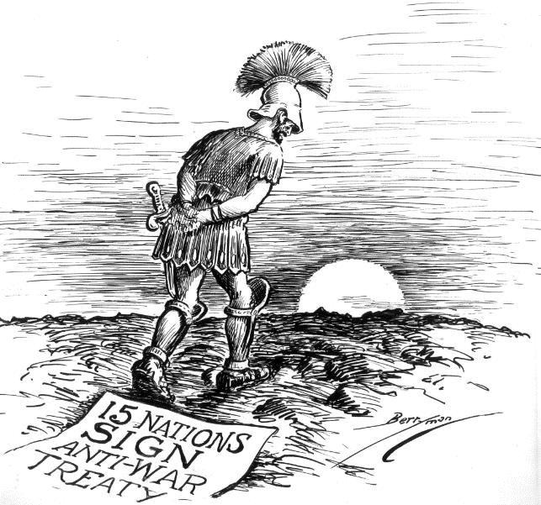

Caption | The Kellogg-Briand Pact was an international treaty  to achieve world peace by outlawing war.
Summary | A figure representing Mars, the Roman god of war, plods sadly across a barren and empty landscape toward the sunset, following news that 15 nations had signed the Kellogg-Briand Pact outlawing war as an instrument of foreign policy. Eventually, 34 additional countries would sign the pact, reflecting an optimistic hope for the prevention of future wars. Public opinion ran strongly in favor of the treaty, and the Senate received many petitions supporting its ratification. Published a decade after history’s most destructive war, Clifford Berryman’s cartoon suggests hope for the future by showing the departure of the god of war, but the somber scene alludes to the vast destruction of the recent world war and tempers any sense of immediate joy.

Graphic Organizer 7: Storm Clouds Gathering – World War II on the Horizon, 1939-1940 – Cartoon 1

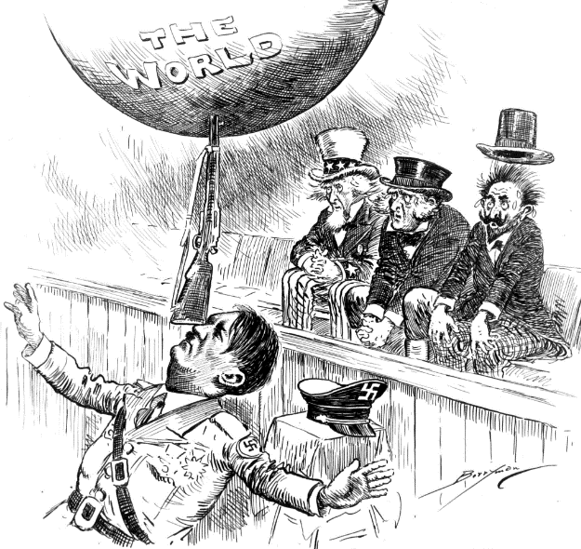

Caption | The aggressive actions of German leader, Adolf Hitler,  shattered post-war hopes for peace.
Summary | By late summer, 1939 Hitler was on the march. This cartoon was published the day after Germany seized control of Slovakia, and as 100,000 German and Slovak troops massed along the Polish border ready to invade. Given the recent history of war, these events raised alarm in France, the United Kingdom, and the United States, represented by the figures in this image. Two days after this cartoon was published the Soviet Union and Germany announced a non-aggression pact, clearing the way for the Nazi invasion of Poland. Clifford Berryman shares Uncle Sam’s worry that American policies of isolation and neutrality would not insulate the country from the Nazi threat.

Graphic Organizer 7: Storm Clouds Gathering – World War II on the Horizon, 1939-1940 – Cartoon 2
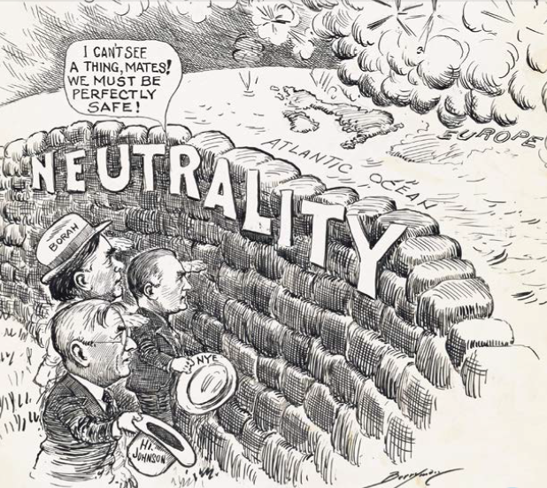

Caption | Seeking to avoid a second world war,  many U.S. leaders supported a policy of neutrality.
Summary | This cartoon shows three prominent isolationist senators staring blindly at a wall labeled, “neutrality,” while embattled Europe is shown engulfed in a cloud of smoke. The figures in the cartoon are William Borah of Idaho, Gerald Nye of North Dakota, and Hiram Johnson of California, Progressive Republican U.S. senators who shared a long history of leading efforts to keep the United States out of international alliances and wars. Borah had opposed the Treaty of Versailles and was against America’s joining the League of Nations. Nye had chaired an investigative committee harshly critical of U.S. entry into the World War I. Johnson sponsored the Neutrality Acts in Congress and opposed President Franklin D. Roosevelt’s proposal to sell planes and arms to France. World War I was fresh in the public memory, and isolationists still resented America’s involvement. In this cartoon, Clifford Berryman mocks the short-sightedness of isolationism.

Graphic Organizer 7: Storm Clouds Gathering – World War II on the Horizon, 1939-1940 – Cartoon 3

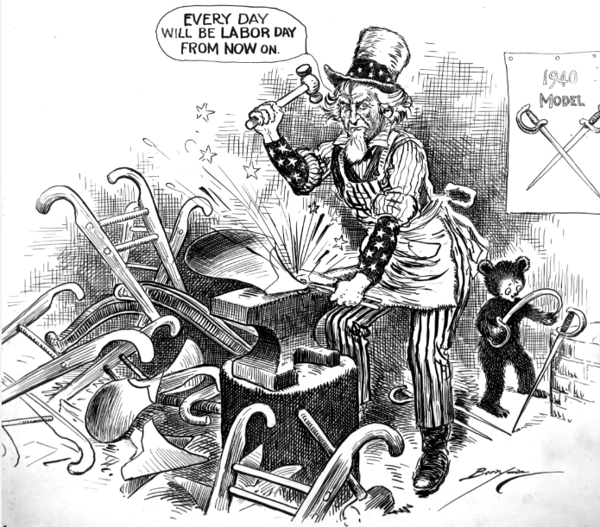

Caption | President Franklin D. Roosevelt proposed supplying arms to republics resisting invasion.
Summary | This cartoon was published on Labor Day, four days after the Senate passed, and as the House debated, the Selective Training and Service Act of 1940. The Act established the first peacetime draft in American history and allowed the government to take over industry for wartime production. This cartoon shows Uncle Sam hammering plows into swords, an inversion of a Bible verse in which nations “hammer swords into plowshares”. By proposing that America produce the “1940 model” sword, Clifford Berryman shows his support for war preparedness efforts. The “Arsenal of Democracy” referred to in this cartoon’s title, became a slogan used by President Franklin D. Roosevelt to describe the nation’s international policy.

Full Document Citations

Article X, cartoon by Clifford Berryman, October 19, 1920; U.S. Senate Collection, Record Group 46; National Archives Building, Washington DC, National Archives Identifier: 6011640.
[https://catalog.archives.gov/id/6011640]
[https://www.docsteach.org/documents/document/article-x]

As Inseparable as Ruth and Naomi, cartoon by Clifford Berryman, March 2, 1900; U.S. Senate Collection, Record Group 46; National Archives Building, Washington DC, National Archives Identifier: 6012445.
[https://catalog.archives.gov/id/6010344]
[https://www.docsteach.org/documents/document/inseparable-ruth-naomi]

Cutting in on the Wire, cartoon by Clifford Berryman, February 24, 1918; U.S. Senate Collection, Record Group 46; National Archives Building, Washington DC, National Archives Identifier: 6011355.
[https://catalog.archives.gov/id/6011355]
[https://www.docsteach.org/documents/document/cutting-wire]

Distribution of The Chinese Pie, cartoon by Clifford Berryman, August 18, 1909; U.S. Senate Collection, Record Group 46; National Archives Building, Washington DC, National Archives Identifier: 6010812.
[https://catalog.archives.gov/id/6010812]
[https://www.docsteach.org/documents/document/distribution-chinese-pie]

In the World Spotlight, cartoon by Clifford Berryman, October 8, 1918; U.S. Senate Collection, Record Group 46; National Archives Building, Washington DC, National Archives Identifier: 6011512.
[https://catalog.archives.gov/id/6011512]
[https://www.docsteach.org/documents/document/world-spotlight]

It’s A Good Act But It’s Hard On The Spectators, cartoon by Clifford Berryman, August 20, 1939; U.S. Senate Collection, Record Group 46; National Archives Building, Washington DC, National Archives Identifier: 6012197.
[https://catalog.archives.gov/id/6012197]
[https://www.docsteach.org/documents/document/good-act-but-hard-spectators]

Kerensky to the Rescue, cartoon by Clifford Berryman, November 13, 1917; U.S. Senate Collection, Record Group 46; National Archives Building, Washington DC, National Archives Identifier: 6011301.
[https://catalog.archives.gov/id/6011301]
[https://www.docsteach.org/documents/document/kerensky-rescue]

Liberty Bonds Save Liberty, cartoon by Clifford Berryman, October 13, 1917; U.S. Senate Collection, Record Group 46; National Archives Building, Washington DC, National Archives Identifier: 6011066.
[https://catalog.archives.gov/id/6011293]
[https://www.docsteach.org/documents/document/liberty-bonds-save-liberty]

The New Peril, cartoon by Clifford Berryman, January 10, 1919; U.S. Senate Collection, Record Group 46; National Archives Building, Washington DC, National Archives Identifier: 6011546.
[https://catalog.archives.gov/id/6011546]
[https://www.docsteach.org/documents/document/new-peril]

Open for Business, cartoon by Clifford Berryman, August 15, 1914; U.S. Senate Collection, Record Group 46; National Archives Building, Washington DC, National Archives Identifier: 6011066.
[https://catalog.archives.gov/id/6011066]
[https://www.docsteach.org/documents/document/open-for-business]

Reporting for Duty, cartoon by Clifford Berryman, April 2, 1917; U.S. Senate Collection, Record Group 46; National Archives Building, Washington DC, National Archives Identifier: 6011220.
[https://catalog.archives.gov/id/6011220]
[https://www.docsteach.org/documents/document/reporting-for-duty]

Ruthless Warfare at Sea, cartoon by Clifford Berryman, February 1, 1917; U.S. Senate Collection, Record Group 46; National Archives Building, Washington DC, National Archives Identifier: 6011066.
[https://catalog.archives.gov/id/6011191]
[https://www.docsteach.org/documents/document/ruthless-warfare-sea]

The Teuton Deduction, cartoon by Clifford Berryman, July 26, 1918; U.S. Senate Collection, Record Group 46; National Archives Building, Washington DC, National Archives Identifier: 6011467.
[https://catalog.archives.gov/id/6011467]
[https://www.docsteach.org/documents/document/teuton-deduction]

Uncle Sam becomes Democracy’s Arsenal, cartoon by Clifford Berryman; U.S. Senate Collection, Record Group 46; National Archives Building, Washington DC, National Archives Identifier: 6012217.
[https://catalog.archives.gov/id/6012217]
[https://www.docsteach.org/documents/document/uncle-sam-becomes-democracys-arsenal]

“Uncle Sam – He wants me to bring him in”, cartoon by Clifford Berryman; U.S. Senate Collection, Record Group 46; National Archives Building, Washington DC, National Archives Identifier: 6012445.
[https://catalog.archives.gov/id/6012445]
[https://www.docsteach.org/documents/document/uncle-sam-berryman-cartoon]

Uncle Sam- “Too late, my boys. I’ve already expanded.”, cartoon by Clifford Berryman, September 14, 1899; U.S. Senate Collection, Record Group 46; National Archives Building, Washington DC, National Archives Identifier: 6010331.
[https://catalog.archives.gov/id/6010331]
[https://www.docsteach.org/documents/document/uncle-samtoo-late-my-boys-ive-already-expanded]

Untitled (Moving Away From War), cartoon by Clifford Berryman, August 27, 1928; U.S. Senate Collection, Record Group 46; National Archives Building, Washington DC, National Archives Identifier: 6011968.
[https://catalog.archives.gov/id/6011968]
[https://www.docsteach.org/documents/document/moving-away-war]

Untitled (Progressive Republics for Neutrality), cartoon by Clifford Berryman, September 7, 1939; U.S. Senate Collection, Record Group 46; National Archives Building, Washington DC, National Archives Identifier: 6012202.
[https://catalog.archives.gov/id/6012202]
[https://www.docsteach.org/documents/document/progressive-republicans-neutrality]

Untitled (Time for American Calmness), cartoon by Clifford Berryman, August 19, 1914; U.S. Senate Collection, Record Group 46; National Archives Building, Washington DC, National Archives Identifier: 6010331.
[https://catalog.archives.gov/id/6011069]
[https://www.docsteach.org/documents/document/time-american-calmness]

The Way of the Neutral is Hard, cartoon by Clifford Berryman, February 13, 1915; U.S. Senate Collection, Record Group 46; National Archives Building, Washington DC, National Archives Identifier: 6010331.
[https://catalog.archives.gov/id/6011098]
[https://www.docsteach.org/documents/document/way-neutral-hard]

Whither?, cartoon by Clifford Berryman, July 13, 1898; U.S. Senate Collection, Record Group 46; National Archives Building, Washington DC, National Archives Identifier: 6010279
[https://catalog.archives.gov/id/6010279]
[https://www.docsteach.org/documents/document/whither-cartoon]

