STUDENTS INVESTIGATING PRIMARY SOURCES – Super Sized!
Big Civics Ideas Through Political Cartoons
How do the political cartoons illustrate big civics ideas?
An Activity for Middle School Civics
Benchmark Correlations
SS.7.C.1.6 – Interpret the intentions of the Preamble of the Constitution
Benchmark Clarification: Students will identify the goals and purposes of government as set forth in the Preamble of the U.S. Constitution.
SS.7.C.2.8 – Identify America’s current political parties, and illustrate their ideas about government.
Benchmark Clarification: Students will evaluate the impact political parties have on society, government, or the political system.
SS.7.C.3.3 – Illustrate the structure and function (three branches of government established in Articles I, II, and III with corresponding powers) of government in the United States as established in the Constitution.
Benchmark Clarification: Students will recognize the structure of the legislative, executive, and judicial branches.
Benchmark Clarification: Students will compare the roles and responsibilities of the three branches of the federal government.
Benchmark Clarification: Students will identify the general powers described in Articles I, II, and III of the U.S. Constitution.
SS.7.C.3.8 – Analyze the structure, functions, and processes of the legislative, executive, and judicial branches.
SS.7.C.3.9 – Illustrate the lawmaking process at the local, state, and federal levels.
Benchmark Clarification: Students will examine the processes of the legislative, executive, and judicial branches of government.
LAFS.7.RI.1.1 – Cite several pieces of textual evidence to support analysis of what the text says explicitly as well as inferences drawn from the text.
LAFS.7.RI.1.3 –Analyze the interactions between individuals, events, and ideas in a text (e.g., how ideas influence individuals or events, or how individuals influence ideas or events).
Time
This SIPS is super sized! This activity will take 1-2 class periods depending on student background knowledge. This activity can be used to introduce big civics concepts or as a review prior to the end-of-course civics assessment. To shorten the activity, reduce the number of stations students visit using fewer cartoons and associated graphic organizers.
Full Document Citations
See Pages 26 and 27
Activity Documents and Handouts
- Big Civics Ideas Graphic Organizer Packets, Pages 3-8, print one copy of all graphic organizers for each student and one additional copy for each station
- Station Placards, Pages 9-25, print one copy of each placard to be cut into three pieces
Teacher Note: Prior to the start of this activity, cut out the political cartoon, caption and summary statement into three separate pieces. Place a copy of one graphic organizer and the related cutouts at each station. Be sure to mix up the political cartoons, captions and summaries at the station so that students have to match the ideas together. If you have multi-colored copier paper available, print the set of political cartoons for each station on the same color paper. This will ensure that cartoons, captions and summary statements don’t get mixed up between stations.
Activity Vocabulary
constituents – people public officials are elected to represent
executive branch – the branch of government that enforces the laws made by the legislative branch and the rulings decided by the judicial branch
federal government – the national level of government; the United States government
Framers – the group of men assembled to write the U.S. Constitution
House of Representatives - the house of the U.S. Congress that represents residents by districts
judicial branch – the branch of government that interprets the laws made by the legislative branch and executive orders signed by the president
legislative branch – the branch of government that makes laws
political party - an organization that tries to get political power by electing members to public office so that their political ideas can become laws or policies
president – the head of the executive branch
Senate – the house of the U.S. Congress that represents residents by states
Speaker of the House – an office identified in Article I, Section 2 of the U.S. Constitution; the leader of the U.S. House of Representatives, usually the highest ranking member of the majority party
- Place students into pairs and pass out the Big Civics Ideas Graphic Organizer Packets, one per student.
- Project the Power Point presentation and use Slides 1-3 to explain to students that they are going to use political cartoons to understand some big civics concepts.
- Project Slide 4 and direct student attention to Graphic Organizer 1. Instruct students to work with their partner to read the paragraph together and circle the civics vocabulary terms.
- Have students share out the terms they identified. Project Slide 5 to ensure that students have circled all of the key civics terms. Teacher Note: Depending on what has already been taught, check to make sure that each student understands the meaning of the terms that they have circled.
- Pose the following question to the students: What can you predict about the political cartoons based on the key civics terms you circled?
- Direct students back to the packet and instruct students to work with their partner to read and circle the key civics terms for the remaining graphic organizers.
- Circulate through the class and check for student understanding of the key civics terms and concepts.
- Use Slides 6-10 of the Power Point to review the remaining graphic organizers as a whole class.
- Create six stations around the room. At each station place a graphic organizer and the corresponding political cartoons, captions and summaries. Teacher Note: Be sure to mix up the political cartoons, captions, and summaries at the station so that students have to match the ideas together.
- Project Slide 11 and merge the student pairs into small groups. You will need six groups total. Place each group at one of the stations.
- Explain to students that they will participate in a carousel activity, moving from one station to the next to connect the political cartoons on their graphic organizers to the correct summary and caption. Share with students that each cartoon illustrates a constitutional power of one of the branches of government.
- Project Slide 12 of the Power Point and instruct students to reread the paragraph on the graphic organizer.
- Project Slide 13 and instruct students to follow the directions on the graphic organizer to match the correct description and caption for each political cartoon and to respond to the question on the graphic organizer: How does the cartoon match the caption? Teacher Note: If needed, model the activity for the students before they begin using a graphic organizer that contains a least three cartoons.
- Provide 5-7 minutes for students to work at their station and complete the graphic organizer.
- Project Slide 14 and have the groups rotate to each station, providing 5-7 minutes for student groups to work at each station.
- Instruct students to return to their seats and work with their group members to make any final notes on their graphic organizers. Rotate through the groups to check student work.
- Close the activity by providing students with the following prompt: “Using one graphic organizer explain how the political cartoons on the graphic organizer relate to each other and to the legislative branch. Write your response in paragraph form and hand it in as an exit slip.”
Enrichment Suggestion: Have students create their own political cartoon illustrating a function of the legislative branch. Instruct students to create a caption and summary to accompany their cartoon.

Name: ____________________________ Date: _____________
Graphic Organizer 1: Congress and the Constitution
The U.S. Constitution divides the federal government into three branches: legislative, executive, and judicial. While the Constitution established a plan for government, the effectiveness of government is the result of how the branches work with and in opposition to each other. Article I of the Constitution outlines the powers of the legislative branch of the government (Congress), and Article II outlines the powers of the executive branch, which includes the presidency.
Directions:
- Match the political cartoon with the correct description. Summarize the description in the box under the cartoon.
- Match each caption with the correct cartoon. Write the caption in the box under the cartoon.
- Respond to the following question and write your answer in the corresponding box: How does the cartoon match the caption?
Cartoon | 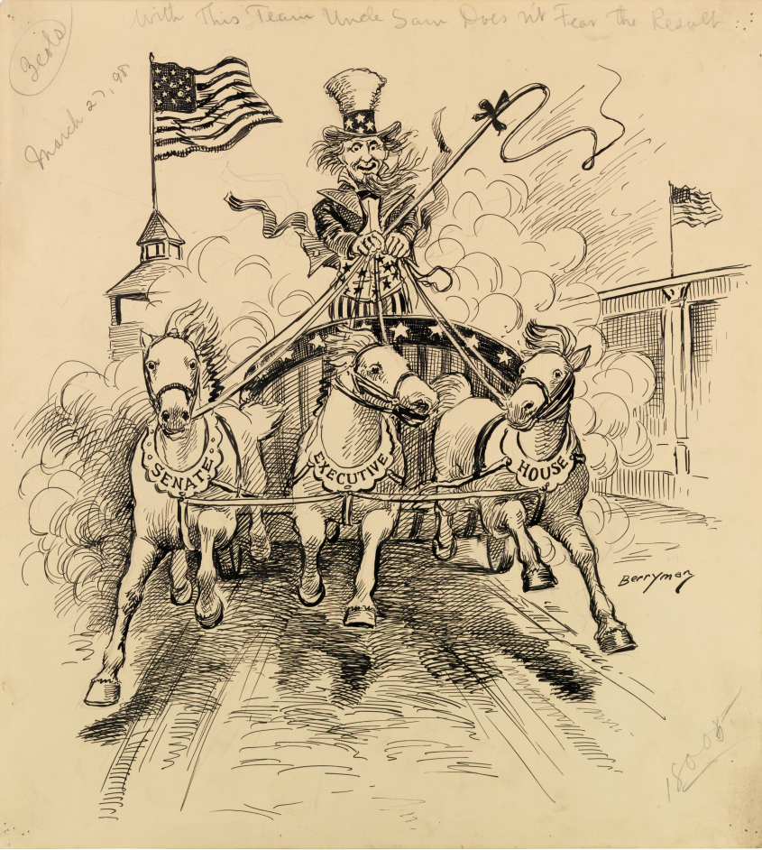 | 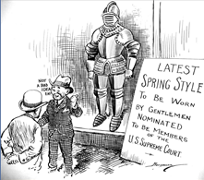 | 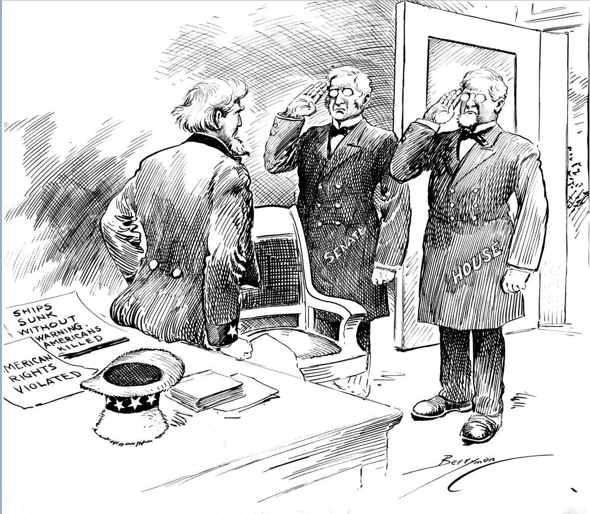
Summary of the Description
Caption
How does the cartoon match the caption?
SS.7.C.3.3
Name: ____________________________ Date: _____________
Graphic Organizer 2: Congress, The Elected, Representative Branch of Government
The Framers created Congress as the representative branch of government with a House of Representatives and a Senate that would represent the people in different ways. Article I of the Constitution establishes the House of Representatives and the Senate as distinct representative bodies with balanced responsibilities and the power to act together to create, or make, legislation. Each of the 435 House members represents a district, while each of 100 Senators represents a whole state. One of the important features of the design is that both houses of Congress must agree on a bill before it goes to the president.
Directions:
- Match the political cartoon with the correct description. Summarize the description in the box under the cartoon.
- Match each caption with the correct cartoon. Write the caption in the box under the cartoon.
- Respond to the following question and write your answer in the corresponding box: How does the cartoon match the caption?
Cartoon | 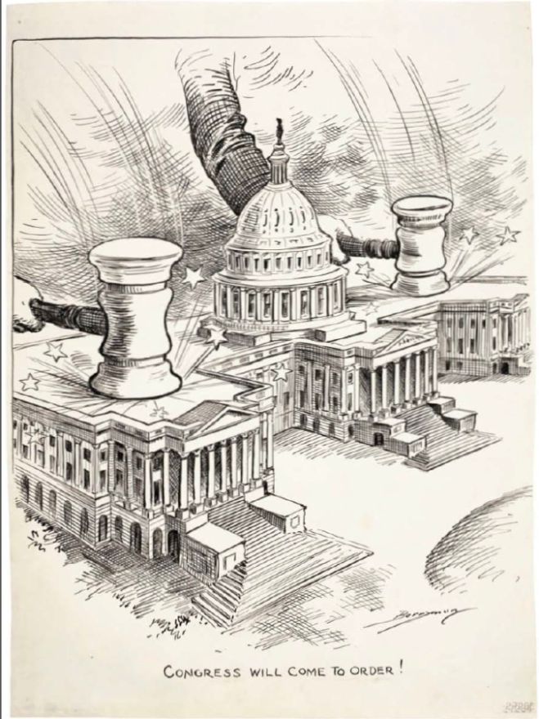 | 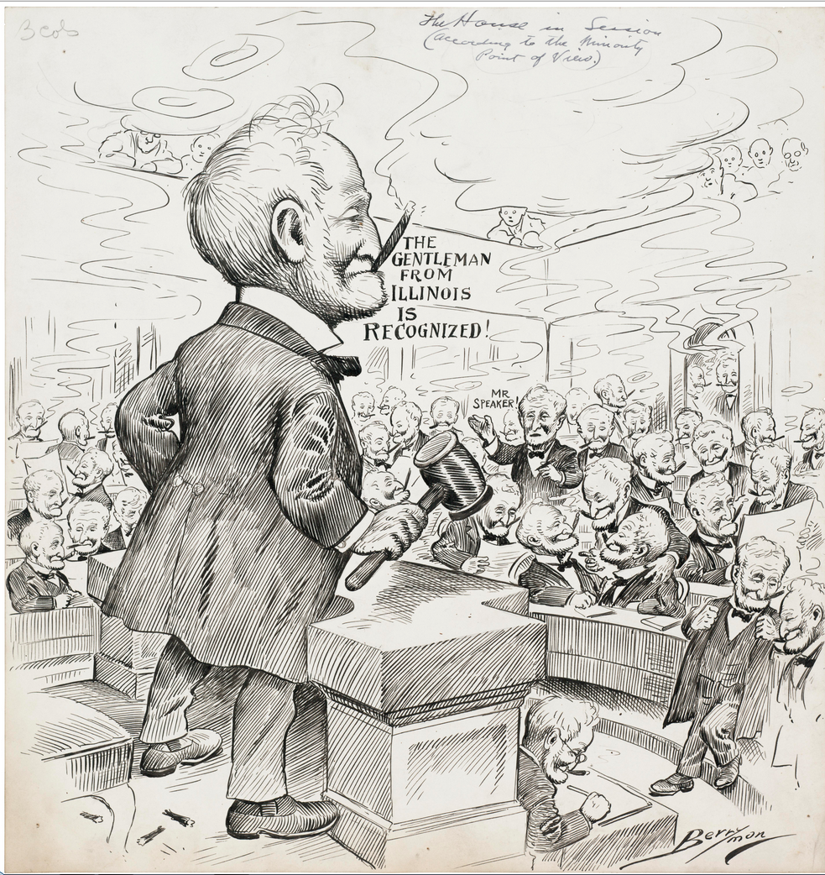 | 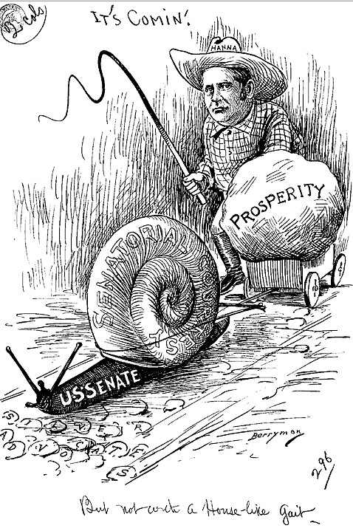
Summary of the Description
Caption
How does the cartoon match the caption?
SS.7.C.3.8
Name: ____________________________ Date: _____________
Graphic Organizer 3: Congress: Making Laws for the Nation
Making laws for the nation is the primary responsibility of Congress. The legislative process in Congress is complex, but it allows every member of the House or Senate to introduce bills. A bill usually advances first to a committee that researches, debates, and amends the bill before reporting a successful bill to the full body for debate, further amending, and then voting. Only a small fraction of bills introduced in Congress become law.
Directions:
- Match the political cartoon with the correct description. Summarize the description in the box under the cartoon.
- Match each caption with the correct cartoon. Write the caption in the box under the cartoon.
- Respond to the following question and write your answer in the corresponding box: How does the cartoon match the caption?
Cartoon | 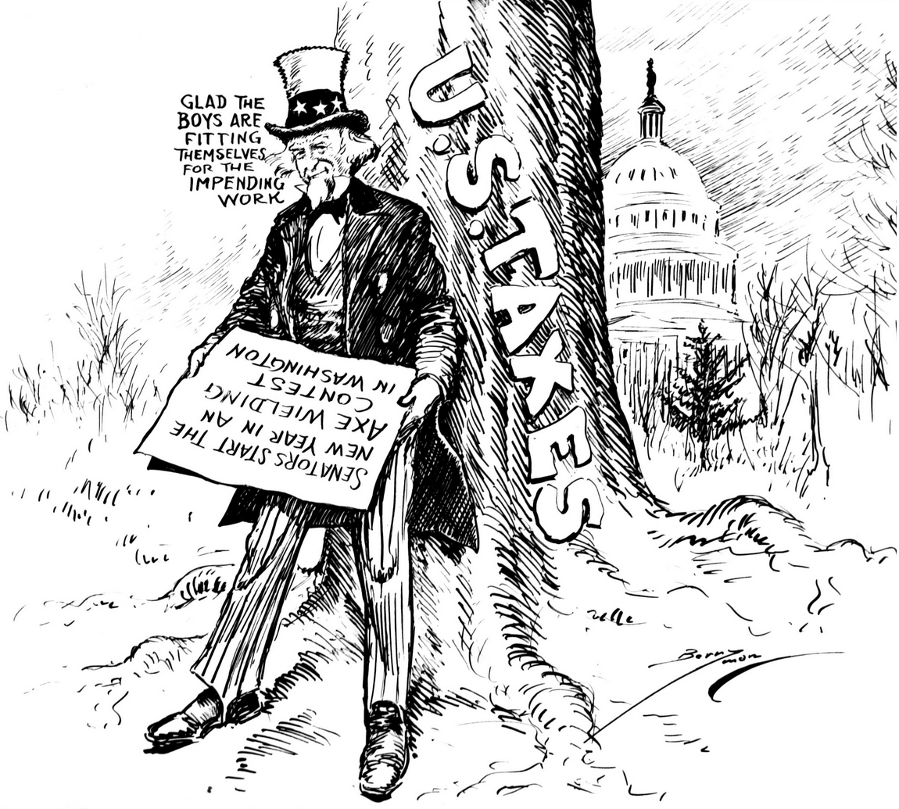 | 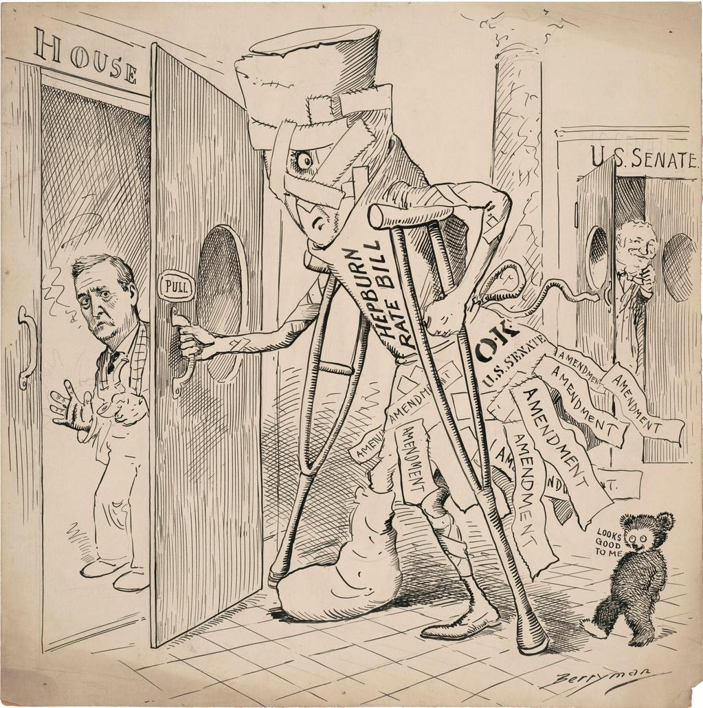
Summary of the Description
Caption
How does the cartoon match the caption?
SS.7.C.3.8 & SS.7.C.3.9

Name: ____________________________ Date: _____________
Graphic Organizer 4: Congress and the President
The Framers separated the legislative and executive powers of the government into two separate branches and created balances between them. Article I of the Constitution outlines the powers of Congress, and Article II outlines those of the president.
Directions:
- Match the political cartoon with the correct description. Summarize the description in the box under the cartoon.
- Match each caption with the correct cartoon. Write the caption in the box under the cartoon.
- Respond to the following question and write your answer in the corresponding box: How does the cartoon match the caption?
Cartoon | 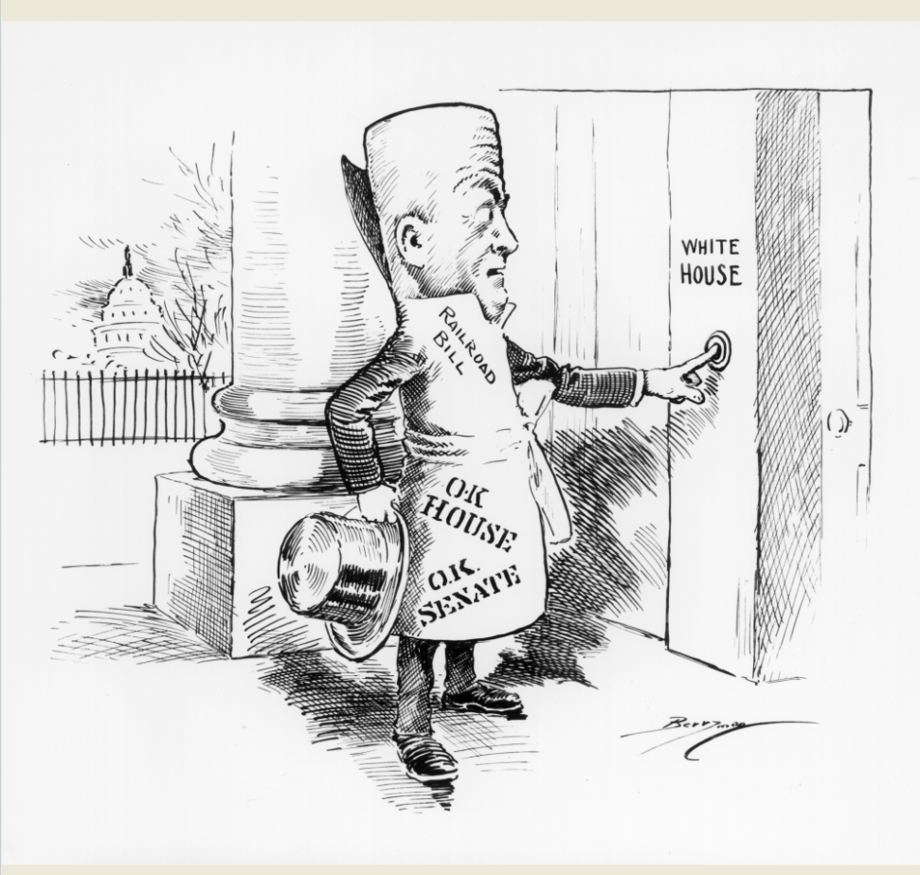 | 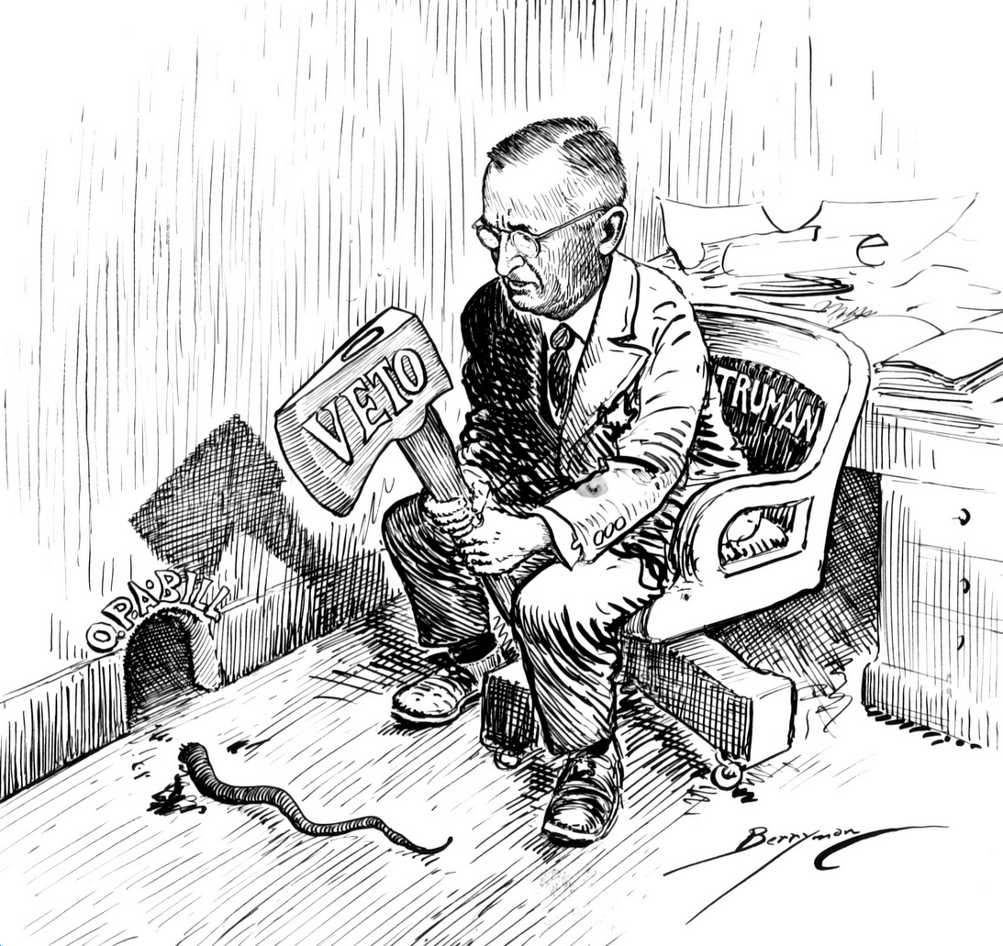 | 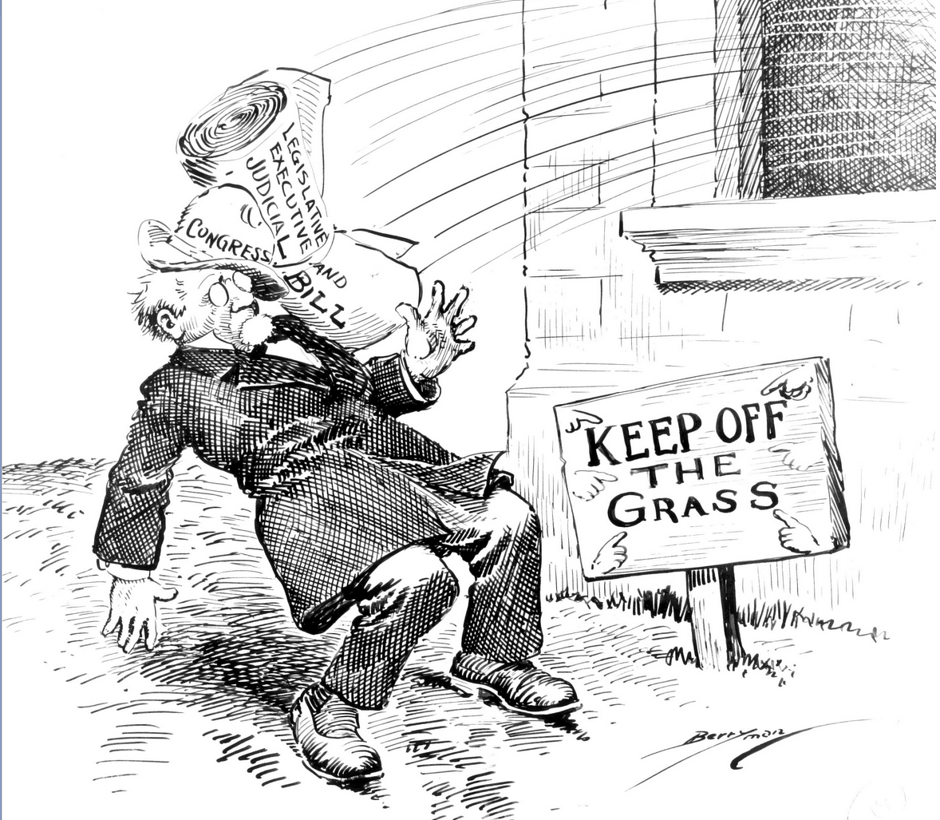
Summary of the Description
Caption
How does the cartoon match the caption?
SS.7.C.3.8 & SS.7.C.3.9

Name: ____________________________ Date: _____________
Graphic Organizer 5: Political Parties
Political parties play a crucial role in shaping how Congress works. In the House of Representatives, the Speaker of the House is usually the highest ranking member of the majority party and the leader of the House of Representatives. The Speaker holds the power in the House and determines the policy agenda. The Senate has a more complicated power structure wherein the majority party sets the schedule, but the minority party can exercise great influence over the pace of events and can prevent many issues from coming to a vote.
Directions:
- Match the political cartoon with the correct description. Summarize the description in the box under the cartoon.
- Match each caption with the correct cartoon. Write the caption in the box under the cartoon.
- Respond to the following question and write your answer in the corresponding box: How does the cartoon match the caption?
Cartoon | 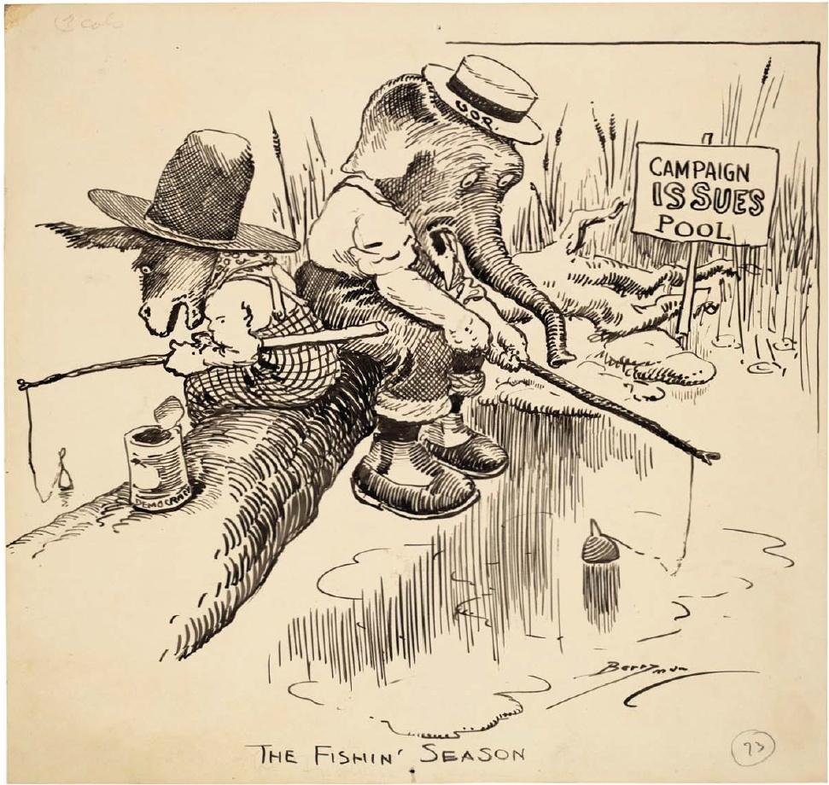 | 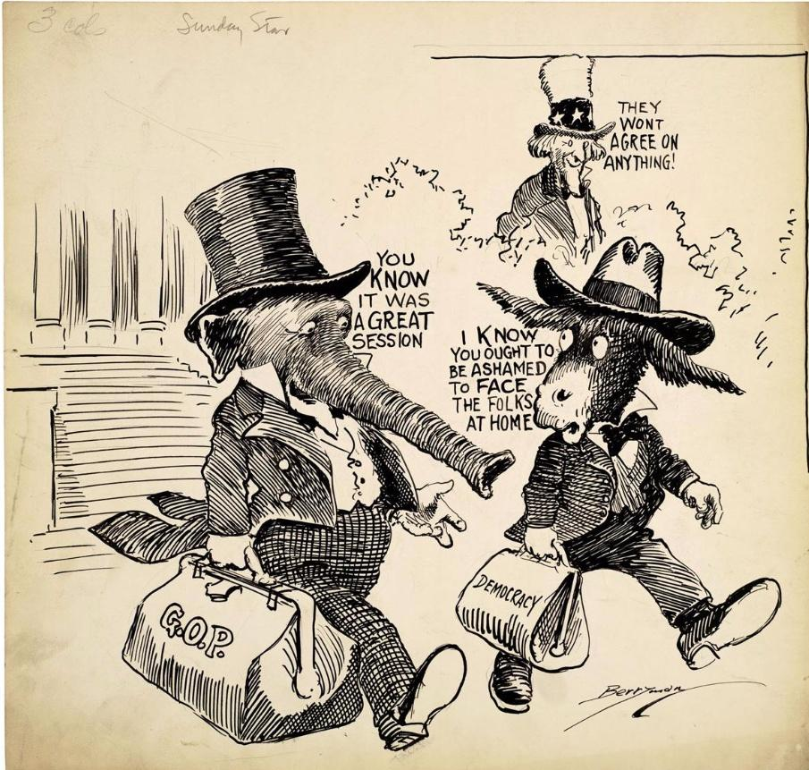 | 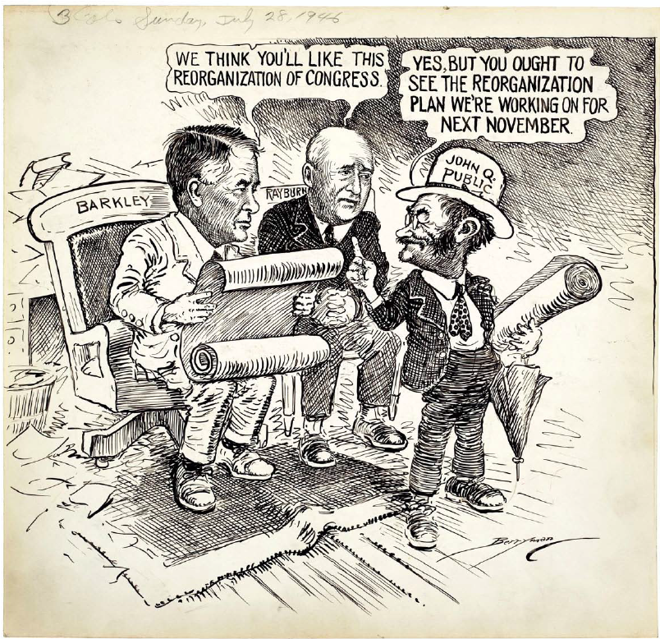
Summary of the Description
Caption
How does the cartoon match the caption?
SS.7.C.2.8 & SS.7.C.3.9

Name: ____________________________ Date: _____________
Graphic Organizer 6: A Member’s Job: Representing the People and the States
Each member of the House and each Senator represents a group of constituents, makes laws for the nation, and participates in fulfilling specific constitutional duties of the House or Senate. House members represent, and are accountable to, the constituents of one of the 435 districts spread across the 50 states, while Senators represent a whole state. Elections give voters the opportunity to evaluate the work of their Representative or Senator or the party in which the Representative or Senator is a member.
Directions:
- Match the political cartoon with the correct description. Summarize the description in the box under the cartoon.
- Match each caption with the correct cartoon. Write the caption in the box under the cartoon.
- Respond to the following question and write your answer in the corresponding box: How does the cartoon match the caption?
Cartoon | 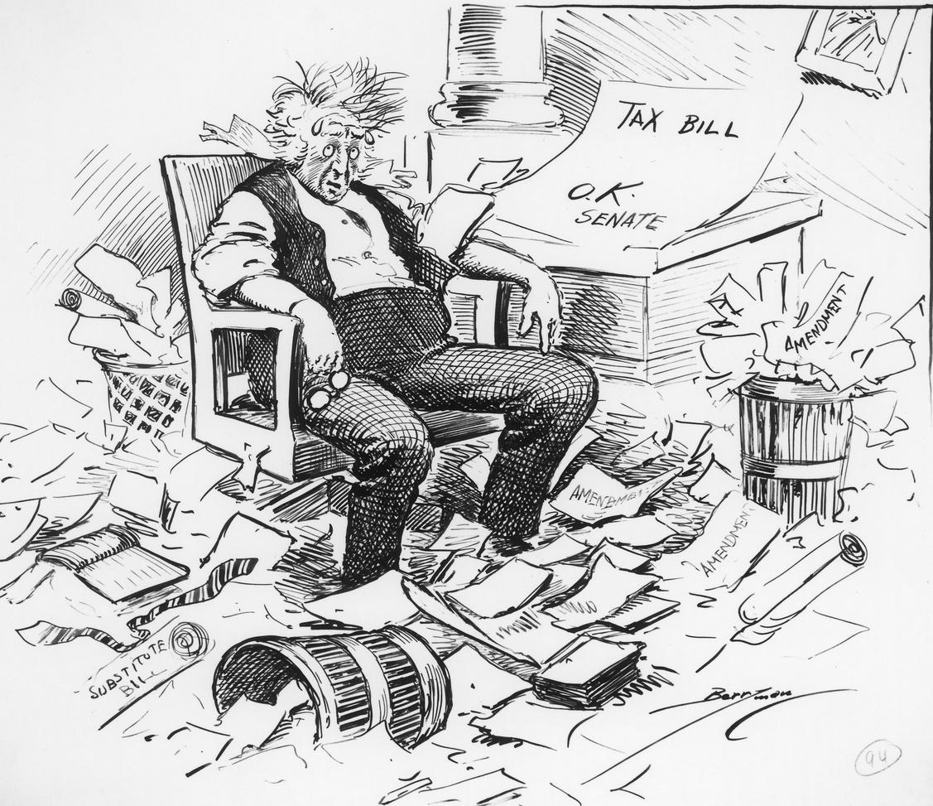 | 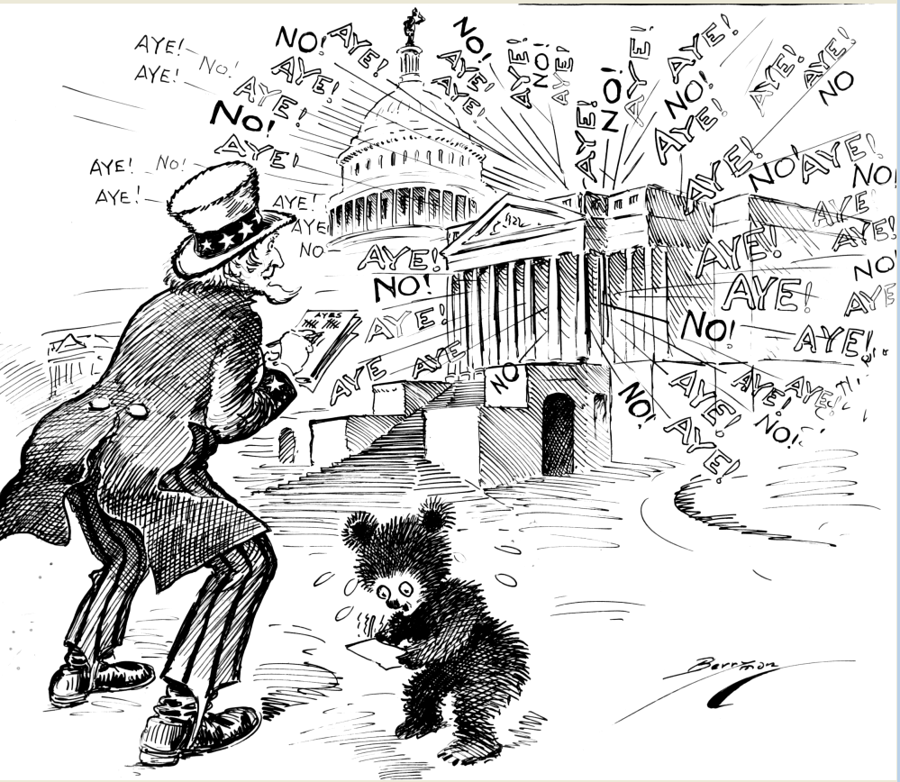 | 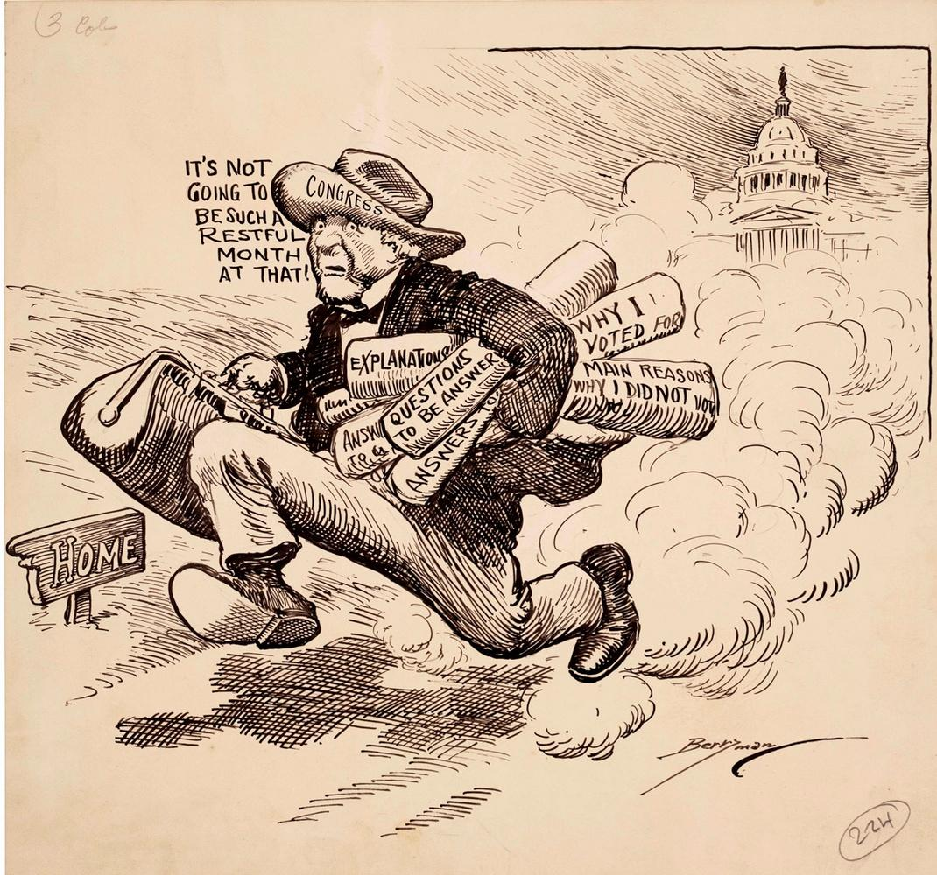
Summary of the Description
Caption
How does the cartoon match the caption?
SS.7.C.1.6 & SS.7.C.3.9

Graphic Organizer 1: Congress and the Constitution – Cartoon 1

Caption | Responsibilities Are Shared Under the Constitution
Summary | The Constitution established branches of government with different powers. Congress makes the laws that the executive branch enforces and the judicial branch interprets. This cartoon depicts the harmony and interdependence of the legislative and executive branches by showing horses working together and pulling Uncle Sam (Uncle Sam = U.S.) representing the nation, around a course.

Graphic Organizer 1: Congress and the Constitution – Cartoon 2

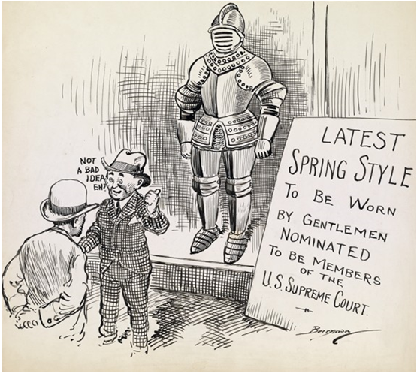

Caption | The Senate Reviews Presidential Appointments
Summary | This cartoon refers to the Senate’s review of individuals nominated to the Supreme Court, but it also could apply to any high official whose appointment is subject to Senate confirmation. The Senate has the constitutional responsibility to evaluate individuals nominated by presidents to serve in high federal offices. Although political divisions within the Senate and between the Senate and the White House have sometimes resulted in contentious nomination hearings, the Constitution mandates that the president and Senate must both agree on the appropriateness for office of every high level appointee.

Graphic Organizer 1: Congress and the Constitution – Cartoon 3

Caption | Congress has the Power to Declare War
Summary | The Constitution vests in Congress—the representative branch—exclusive power to declare war. Congress’s war power also illustrates the separate powers and responsibilities of Congress and the president. As Commander in Chief of the armed forces, the President implements and is bound by the goals, means, and limitations Congress specifies in the declaration of war. In this cartoon, the House and Senate report to Uncle Sam (Uncle Sam = U.S.), a symbol of the nation, not the president.

Graphic Organizer 2: Congress, The Elected, Representative Branch of Government - Cartoon 1

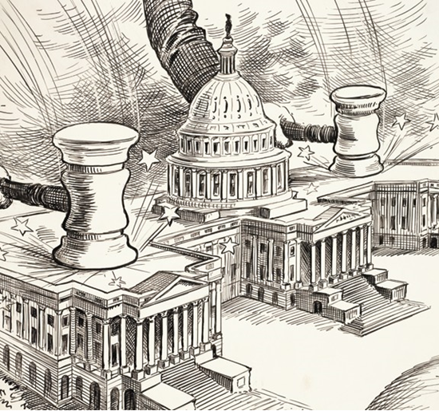

Caption | Congress is the People’s Representative Assembly
Summary | A new Congress assembles every two years when voters elect the entire House of Representatives and one-third of the Senate. The House and the Senate share legislative powers but have different rules and procedures. The House represents the people in their congressional districts, and the Senate represents them as residents of their states. As the representative branch of government, Congress taxes, decides how the government should spend public monies, keeps track of past spending, and serves as a public forum wherein all the great issues facing the nation are debated.

Graphic Organizer 2: Congress, The Elected, Representative Branch of Government - Cartoon 2

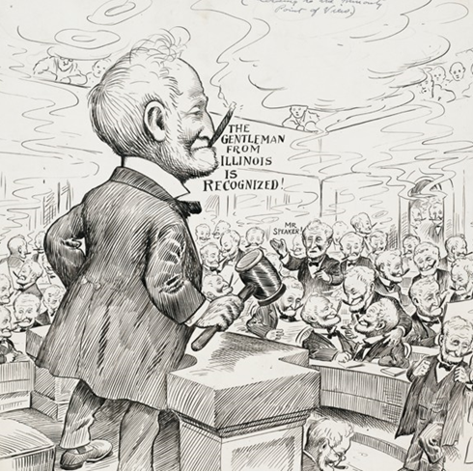

Caption | The Speaker Leads the House by Majority Rule
Summary | Led by a powerful Speaker of the House whose party holds the majority of seats, the House of Representatives often works at a faster pace than the Senate and frequently leaves the minority party limited influence. This cartoon depicts the House under its most powerful Speaker to that point, Joseph G. Cannon of Illinois, who led the Republican majority in the House from 1903 to 1911.

Graphic Organizer 2: Congress, The Elected, Representative Branch of Government - Cartoon 3
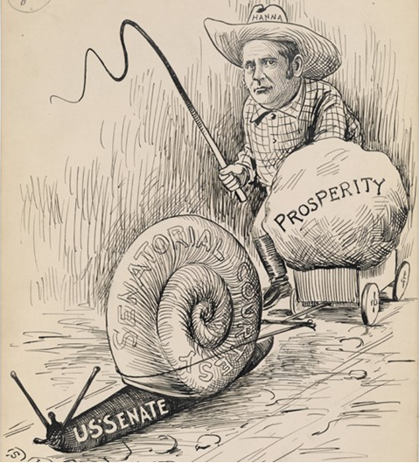

Caption | All Senators are Equal, and Senate Minorities are Protected
Summary | The Senate operates in a manner and at a pace far different from the House. Senators represent states and serve staggered six-year terms, which means that only one-third of the Senators face reelection every two years. The Senate Majority Leader typically has less power than the Speaker of the House, Senate rules recognize the equality of all Senators, and Senate procedures protect the power of the minority. This 1897 caricature shows the slow deliberative pace of the Senate.

Graphic Organizer 3: Congress: Making Laws for the Nation – Cartoon 1
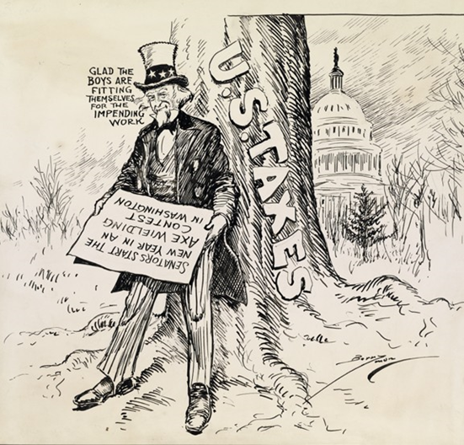

Caption | Congress Makes the Nation’s Spending and Taxing Bills
Summary | The power to tax balances Congress’s power to appropriate money for spending. Article I, Section 8, of the Constitution grants Congress power to “lay and collect taxes.” Article I, Section 7 specifies that tax legislation must originate in the House of Representatives. Since the beginning of the United States, Congress has grappled with which taxes should be levied, how much revenue should be raised, and who should bear the greatest tax burden. This cartoon shows Uncle Sam hoping that Congress is prepared to take an ax to taxes.

Graphic Organizer 3: Congress: Making Laws for the Nation – Cartoon 2
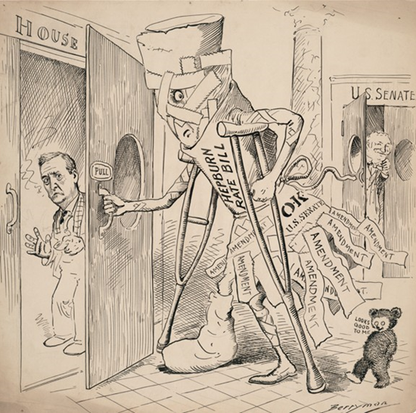

Caption | Amended Bills Reflect Compromises when Passed
Summary | The legislative process established in the Constitution requires that each bill pass through rigorous procedures in both houses of Congress, including opportunities to add amendments. A bill’s journey through Congress is not complete until both houses have passed it in identical form. This cartoon depicts a bill that has been amended so much in the Senate that it is practically unrecognizable to its original House author.

Graphic Organizer 4: Congress and the President – Cartoon 1

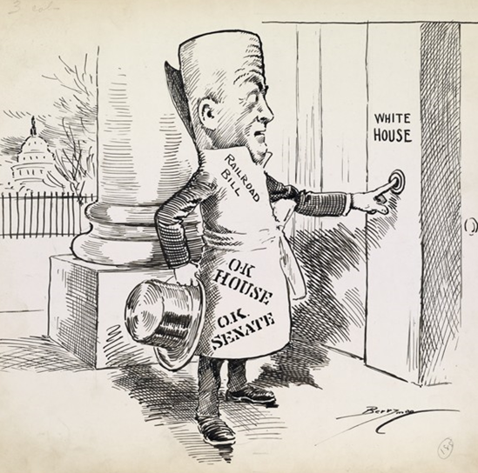

Caption | Successful Bills Become Laws with the President’s Signature
Summary | Even when a bill has cleared all the hurdles in the legislative process through both houses of Congress, it still requires the signature of the President to become law. Only a small percentage of bills introduced in any Congress make it this far in the legislative process. This cartoon conveys a railroad bill’s anxiety about how it will be received by the President.

Graphic Organizer 4: Congress and the President – Cartoon 2

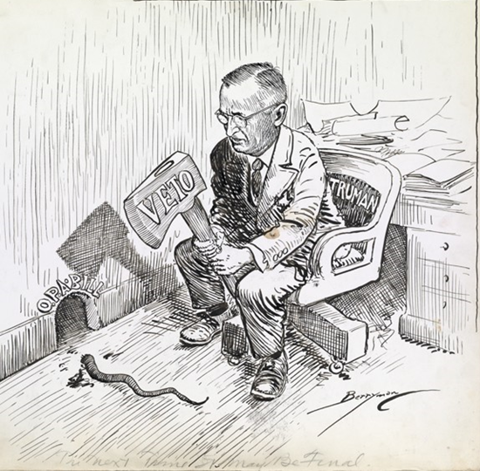

Caption | A President’s Objection (Veto) Return a Bill to Congress
Summary | Veto power—derived from the Latin phrase “I forbid”—gives the President the authority to veto legislation. This executive power over a legislative action is an example of a constitutional check by one branch upon the authority of another. The Founders designed the Constitution with multiple checks and balances to ensure that no one branch can independently exert control of the government.

Graphic Organizer 4: Congress and the President – Cartoon 3
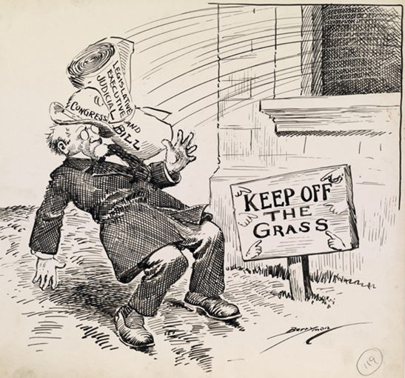

Caption | Congress Can Reconsider a Returned Bill and Override a Veto
Summary | When a President vetoes a piece of legislation—provided that the action takes place within 10 days of the bill being presented to the president (Sundays excepted)—it is returned to the chamber of Congress where it originated along with a statement of why the president objects to it. That chamber then has an opportunity to override the president’s veto. If the vote results in at least a two-thirds majority, it is sent to the other chamber where another override vote takes place. With a minimum two-thirds majority in that chamber as well, the bill becomes law without the President’s signature.

Graphic Organizer 5: Political Parties – Cartoon 1

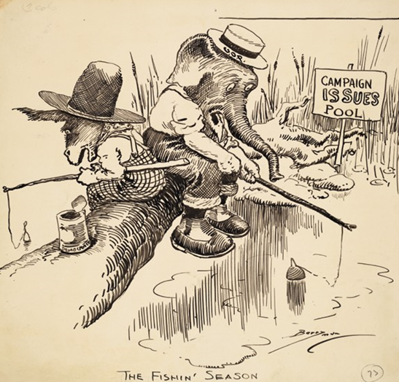

Caption | Each Party Seeks Issues that Will Lure Voters
Summary | Political parties try to win elections by choosing and angling for issues that will appeal to voters. This cartoon shows the two parties on the lookout for issues that will lure undecided voters to their side and away from the other party.

Graphic Organizer 5: Political Parties – Cartoon 2
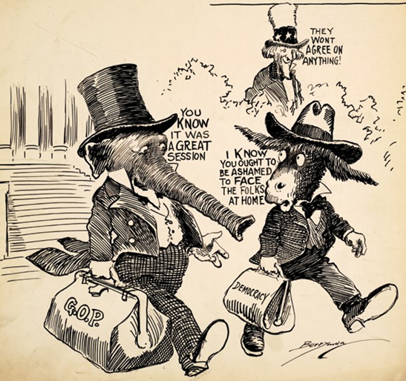

Caption | Party Rivalry Reflects the Range of Opinions on Issues
Summary | The rivalry between the two parties is a regular feature of congressional politics, and Democrats and Republicans often view congressional action and legislation from opposite perspectives. Going home at the end of the session, the two characters depicted in this cartoon have very different opinions about the results of the session. Despite their differences, both parties contribute to the work of Congress, with the minority party often suggesting policy alternatives and blocking bills that lack needed support to pass.

Graphic Organizer 5: Political Parties – Cartoon 3

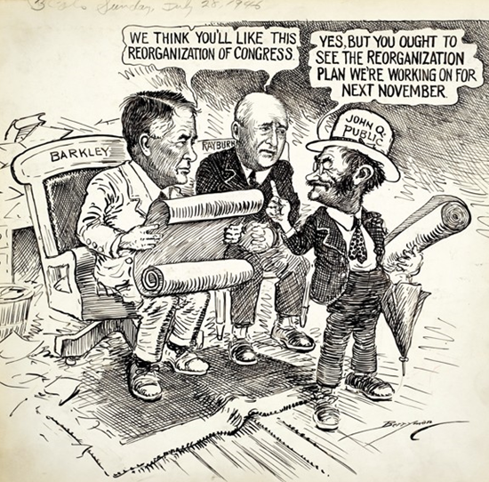

Caption | The People Show Their Support for Each Party When They Vote
Summary | Having the voters choose their representatives is an important way that the ideal of popular sovereignty is translated into political reality. Each election allows the voters to take stock of the work of their representatives, and every two years voters have a chance to evaluate the work of their representatives in Congress.

Graphic Organizer 6: A Member’s Job: Representing the People and the States – Cartoon 1

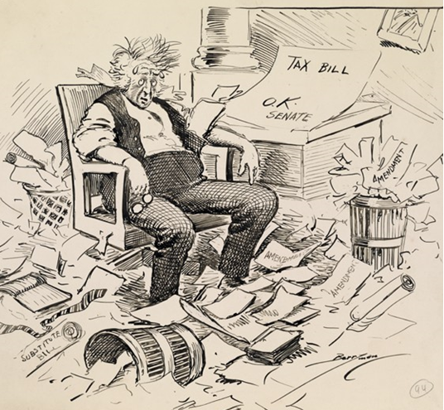

Caption | Each Member Juggles a Wide Range of Responsibilities
Summary | Whether in the majority or minority party, each Representative or Senator must juggle a wide range of demanding daily tasks related to the needs of constituents, their district or state, and the nation. Each member must keep informed about bills on many topics, participate in the work of committees and fulfill numerous other responsibilities. Also, if the member of Congress is running for re-election, they must raise money for the next election campaign.

Graphic Organizer 6: A Member’s Job: Representing the People and the States – Cartoon 2

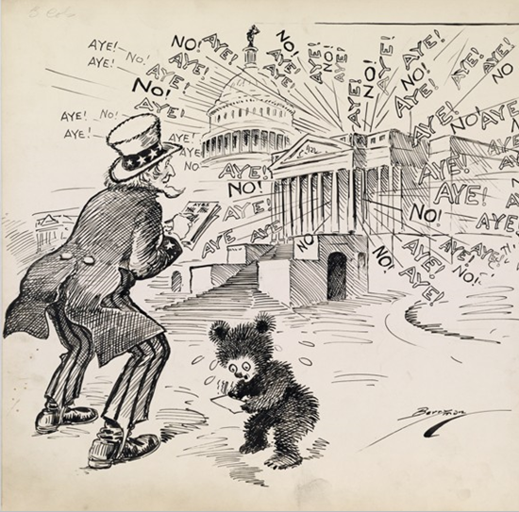

Caption | Casting Votes is the Defining Duty of a Member
Summary | Voting is the engine of democracy. Decisions at all levels of government are based on this expression of popular will. The House and Senate take many votes on each measure they debate. Votes in committee lead to votes in the full House and additional votes in the Senate. Typically, by the time a law is passed, members of Congress have had many opportunities to demonstrate their support or opposition.

Graphic Organizer 6: A Member’s Job: Representing the People and the States – Cartoon 3

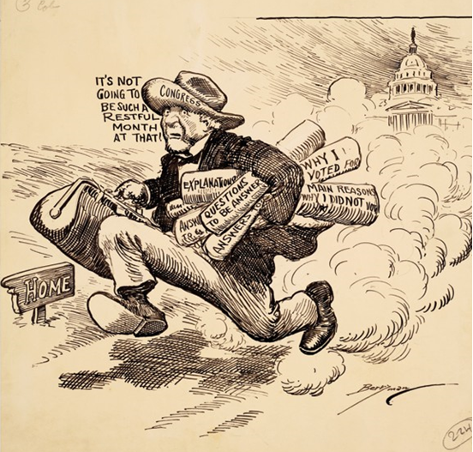

Caption | Communicating with Voters is the Key to Reelection
Summary | Communicating with constituents is a critical element of representation. Members of the House and Senate are busy addressing many complex issues on behalf of voters. When they return home from Washington, they must explain the actions they took, decisions they made, and their thoughts and plans for the future. This cartoon shows that the Members’ work does not end when Congress is in recess.

Full Document Citations

Anyone Home?, cartoon by Clifford Berryman, February 24, 1920; U.S. Senate Collection, Record Group 46; National Archives Building, Washington DC, National Archives Identifier: 6011590.
[https://catalog.archives.gov/id/6011590]
[https://www.docsteach.org/documents/document/anyone-home]

Congress Comes to Order, cartoon by Clifford Berryman, December 2, 1912; U.S. Senate Collection, Record Group 46; National Archives Building, Washington DC, National Archives Identifier: 306178.
[https://catalog.archives.gov/id/306178]
[https://www.docsteach.org/documents/document/congress-will-come-to-order]

Congress Wields Ax at Taxes, cartoon by Clifford Berryman, June 2, 1924; U.S. Senate Collection, Record Group 46; National Archives Building, Washington DC, National Archives Identifier: 6011829
[https://catalog.archives.gov/id/6011829]
[https://www.docsteach.org/documents/document/congress-wields-ax-taxes]

Hepburn Rate Bill, cartoon by Clifford Berryman, May 15, 1906; U.S. Senate Collection, Record Group 46; National Archives Building, Washington DC, National Archives Identifier: 6010631
[https://catalog.archives.gov/id/6010631]
[https://www.docsteach.org/documents/document/congress-wields-ax-taxes]

It’s Comin’. But Not with a House-like Gait, cartoon by Clifford Berryman, May 29, 1897; U.S. Senate Collection, Record Group 46; National Archives Building, Washington DC, National Archives Identifier: 306161.
[https://catalog.archives.gov/id/306161]
[https://www.docsteach.org/documents/document/its-comin-but-not-with-a-houselike-gait]

It’s Not Going to be Such a Restful Month at That, cartoon by Clifford Berryman, August 25, 1921; U.S. Senate Collection, Record Group 46; National Archives Building, Washington DC, National Archives Identifier: 1693447.
[https://catalog.archives.gov/id/1693447]
[https://www.docsteach.org/documents/document/its-not-going-to-be-such-a-restful-month-at-that]

Reporting for Duty, cartoon by Clifford Berryman, April 2, 1917; U.S. Senate Collection, Record Group 46; National Archives Building, Washington DC, National Archives Identifier: 6011220.
[https://catalog.archives.gov/id/6011220]
[https://www.docsteach.org/documents/document/reporting-for-duty]

The Fishin’ Season, cartoon by Clifford Berryman, June 7, 1919; U.S. Senate Collection, Record Group 46; National Archives Building, Washington DC, National Archives Identifier: 1693475
[https://catalog.archives.gov/id/1693475]
[https://www.docsteach.org/documents/document/the-fishin-season]

The House in Session (According to the Minority Point of View), cartoon by Clifford Berryman, April 16, 1908; U.S. Senate Collection, Record Group 46; National Archives Building, Washington DC, National Archives Identifier: 6010752.
[https://catalog.archives.gov/id/6010752]
[https://www.docsteach.org/documents/document/the-house-in-session-minority-point-of-view]

The Next Time It May Be Final, cartoon by Clifford Berryman, July 14, 1946; U.S. Senate Collection, Record Group 46; National Archives Building, Washington DC, National Archives Identifier: 6012355.
[https://catalog.archives.gov/id/6012355]
[https://www.docsteach.org/documents/document/next-time-may-be-final]

They Won’t Agree on Anything!, cartoon by Clifford Berryman, September 24, 1922; U.S. Senate Collection, Record Group 46; National Archives Building, Washington DC, National Archives Identifier: 1693523
[https://catalog.archives.gov/id/1693523]
[https://www.docsteach.org/documents/document/they-wont-agree-on-anything]

This is the Team that Will Win Every Time, cartoon by Clifford Berryman, March 27, 1898; U.S. Senate Collection, Record Group 46; National Archives Building, Washington DC, National Archives Identifier: 6010254.
[https://catalog.archives.gov/id/6010254]
[https://www.docsteach.org/documents/document/team-win]

Untitled [Keep off the Grass], cartoon by Clifford Berryman, May 14, 1920; U.S. Senate Collection, Record Group 46; National Archives Building, Washington DC, National Archives Identifier: 6011611.
[https://catalog.archives.gov/id/6011611]
[https://www.docsteach.org/documents/document/keep-off-the-grass]

Untitled [Reorganization of Congress], cartoon by Clifford Berryman, July 28, 1946; U.S. Senate Collection, Record Group 46; National Archives Building, Washington DC, National Archives Identifier: 306100.
[https://catalog.archives.gov/id/306100]
[https://www.docsteach.org/documents/document/reorganization-of-congress]

Untitled [Suit of Armor], cartoon by Clifford Berryman, April 15, 1930; U.S. Senate Collection, Record Group 46; National Archives Building, Washington DC, National Archives Identifier: 6012025.
[https://catalog.archives.gov/id/6012025]
[https://www.docsteach.org/documents/document/latest-spring-style]

Untitled [Tax Bill], cartoon by Clifford Berryman, November 8, 1921; U.S. Senate Collection, Record Group 46; National Archives Building, Washington DC, National Archives Identifier: 6011694.
[https://catalog.archives.gov/id/6011694]
[https://www.docsteach.org/documents/document/tax-bill]

Vote on Military Bonus Plan, cartoon by Clifford Berryman, March 24, 1922; U.S. Senate Collection, Record Group 46; National Archives Building, Washington DC, National Archives Identifier: 6011718.
[https://catalog.archives.gov/id/6011718]
[https://www.docsteach.org/documents/document/vote-military-bonus-plan]

